Course Letter-# Unit #: Name of Unit

Summary:
EXAMPLE Summary: This unit will focus on how the MEDL should prepare for responding to an incident and how to check in when they first arrive.

Objectives:
- Describe basic terminology used in wildland fire.
- Describe the elements of the fire triangle.
- Describe the methods of heat transfer.

Unit at a Glance:
Topics | Method | Duration
Unit Overview | Presentation | # Minutes
The Fire Triangle | Presentation  and Group Activity | # Minutes
Breaking the Fire Triangle | Video and Discussion | # Minutes
Methods of Heat Transfer | Presentation | # Minutes
Suppression Terminology | Presentation | # Minutes
Knowledge Check | Group Activity | # Minutes
Total Unit Duration |  | Total # Minutes

Preparation:
This section appears at the beginning of the course and unit. It indicates all steps you need to take to prepare for delivery.

Course Materials:
Exercise 1 Handout – 1 per student
Handheld Radio

Classroom:
- Ability to display images and video on large screen.
- White board or easel access for group breakout.

Key

Headings with icons:
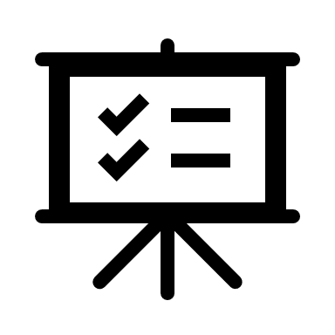Review

Handout

Reference Standard

Group Discussion

Play Video

Activity

General formatting

Styles included in this template:

Heading 1

Heading 2

Heading3
Body Text
- Box list
Question:
Answer:

Lists
- When you are ready to start typing a numbered or bulleted list, place the cursor in the location you want to begin the list. Select the appropriate style (list number or list bullet) from the Styles Group. This will automatically begin your list at the first level. Use the increase and decrease indent buttons in the paragraph menu or the tab key to set a new level bullet.
  - The second and third bullets are set.
    - Limit going beyond the third bullet.
      - Use the fourth bullet if necessary.
Only use automatic numbering when there are at least two levels. Numbered lists follow this sequence, which can be chosen from the Multi-level Lists:
- Level one
  - Level two
    - Level three
      - Level four

Example Title Slide
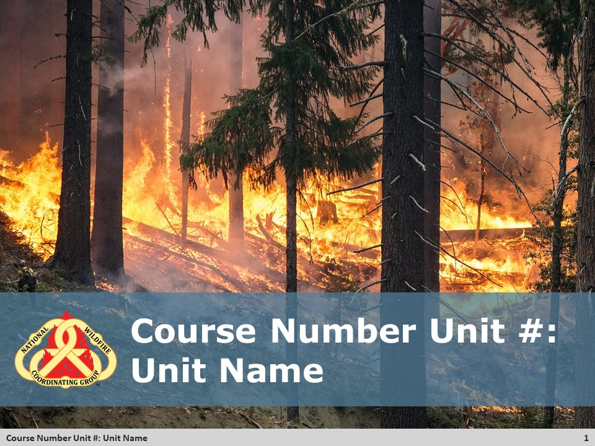
Unit Overview
EXAMPLE Summary: This unit will focus on how the MEDL should prepare for responding to an incident and how to check in when they first arrive.
EXAMPLE Methodology: It begins with the dispatch for a single resource MEDL unit. It will then review what the MEDL needs to do to prepare for being away at the incident and what information they should gather before they leave. It concludes with the steps of the check-in process when arriving at the incident.

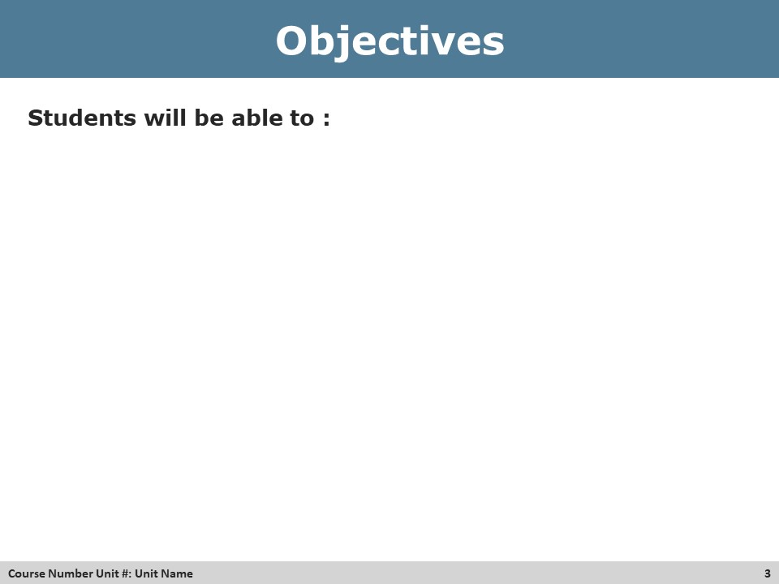
Review Unit Objectives
By the end of this unit students will be able to:
- List objectives
Handout
List materials to handout. Make sure they are also in the materials list for the unit.
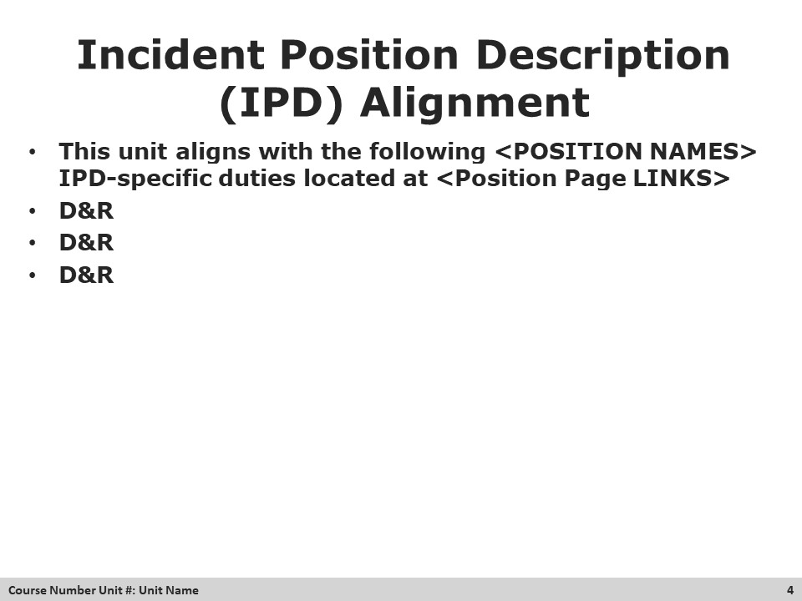
List the IPD statements that align to this unit.
Example: Duties and Responsibilities Addressed in Unit
D&R #1 Ensure individual readiness.
D&R #2 Gather critical state, regional and local emergency medical system (EMS) resource information, regulations, and response capabilities.
D&R #3 Travel to and check in at assignment.

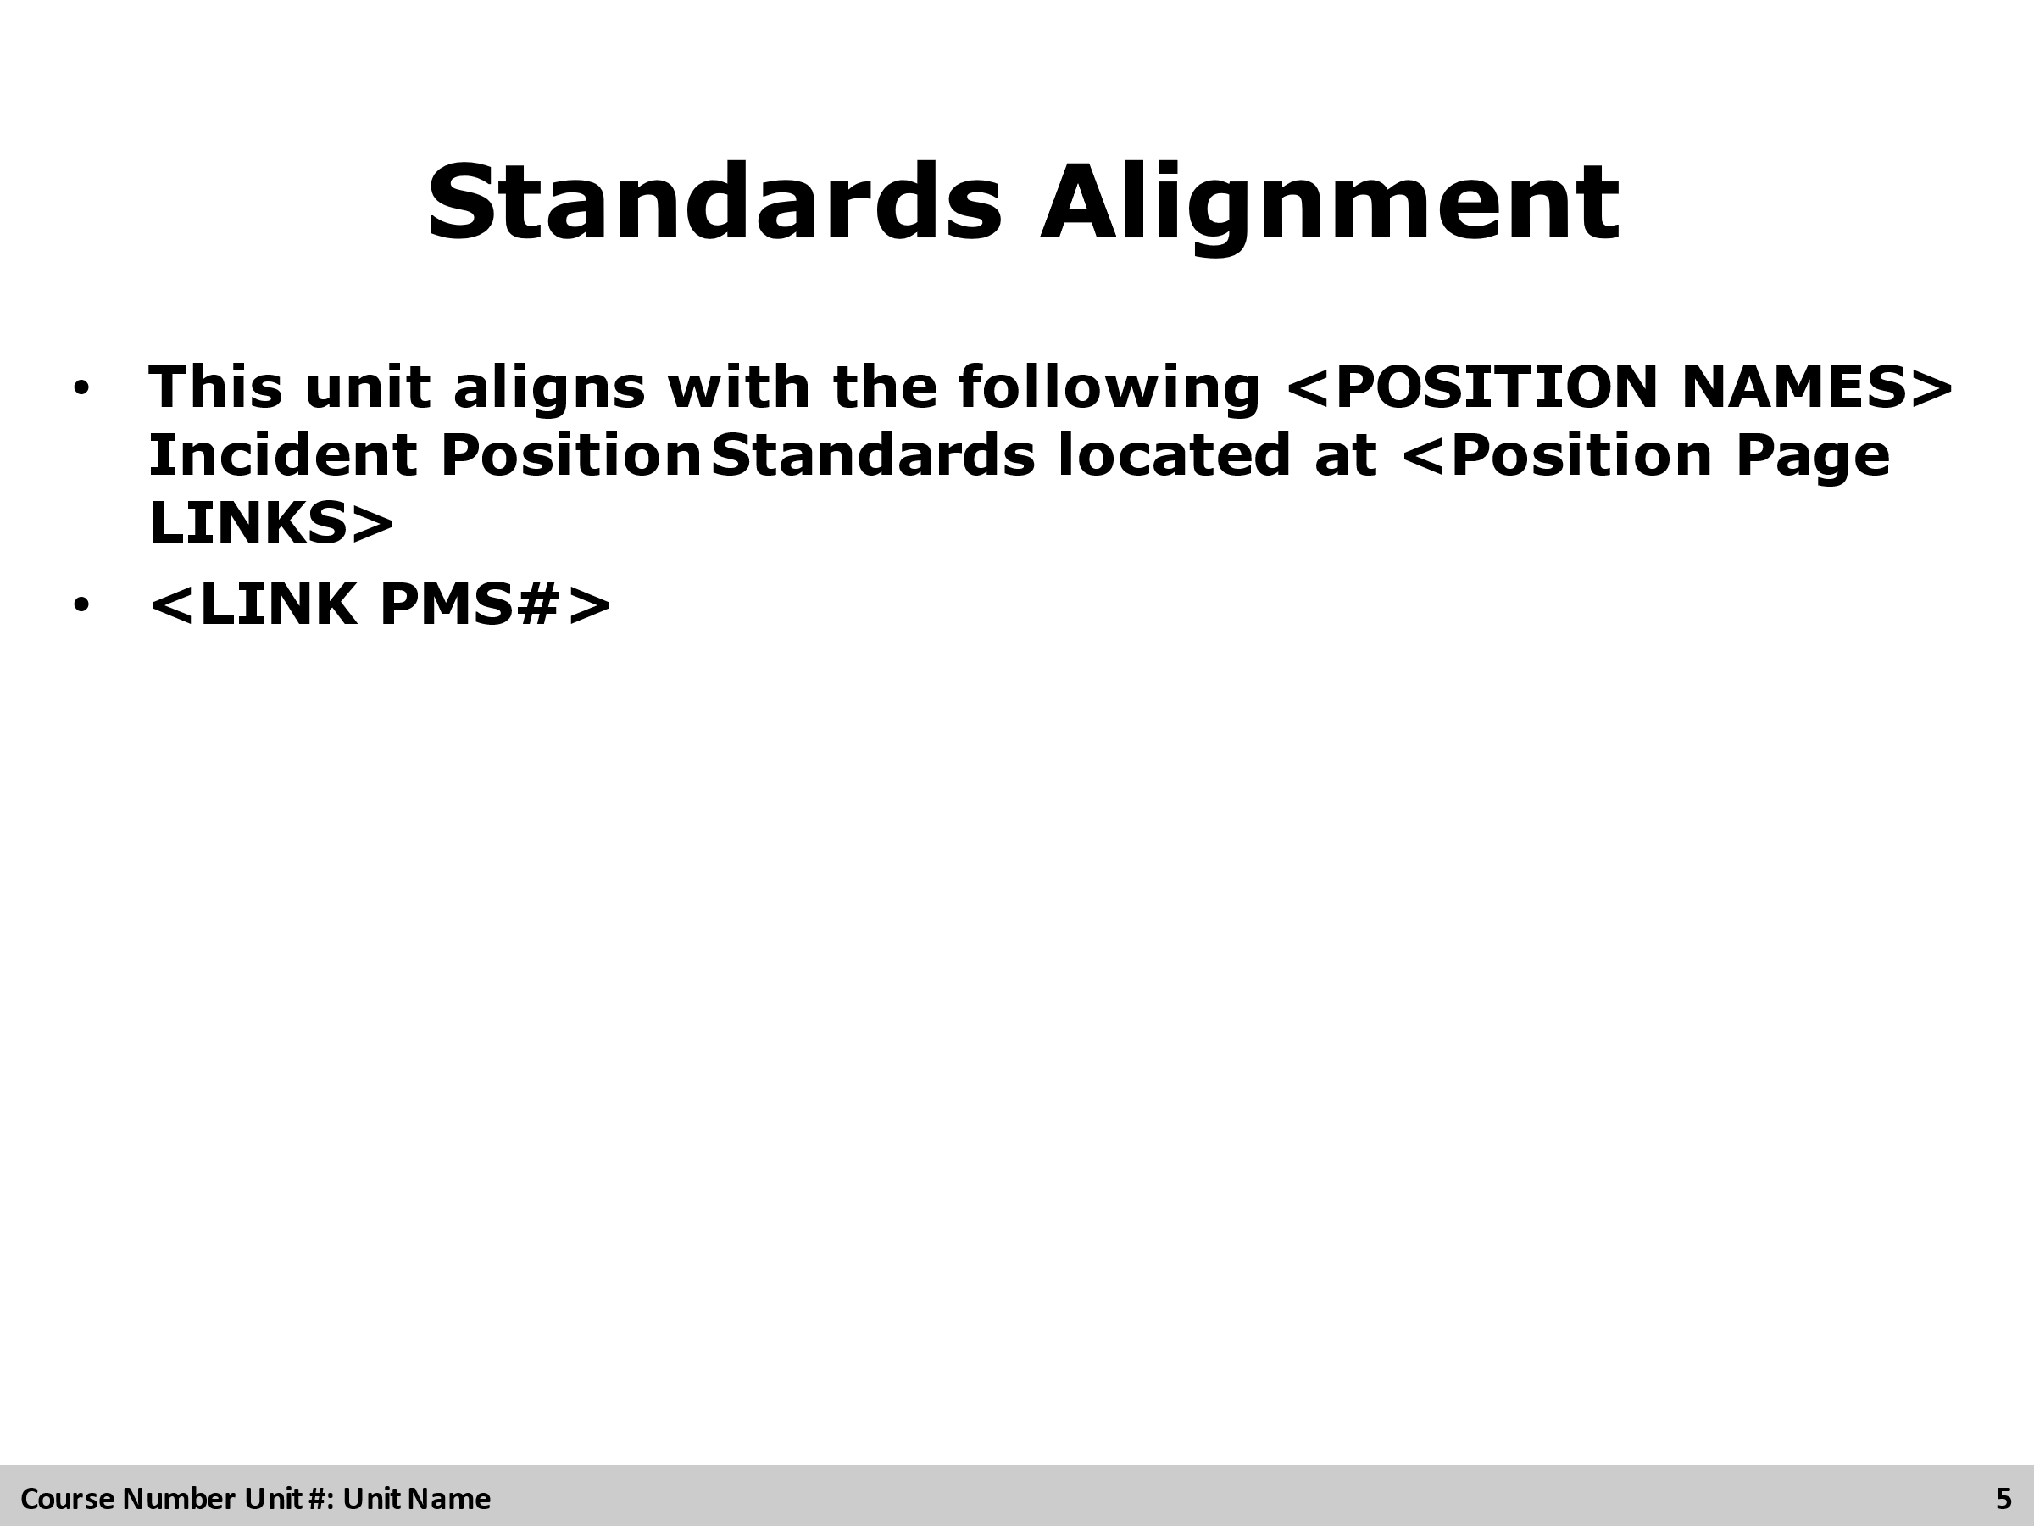
Reference Standard
List the standards to be referenced. Make sure they are also in the materials list for the unit.

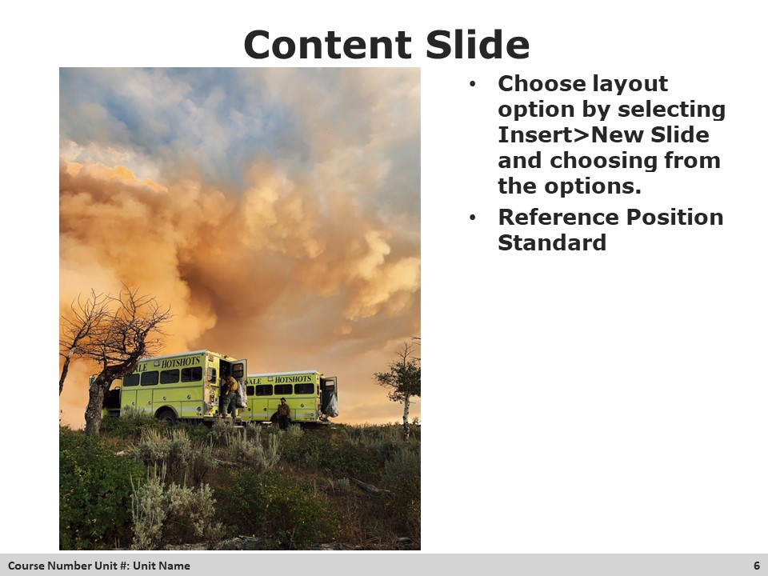
Group Discussion
- Invite students to participate in the following question/topics/discussion points.
Question: Write question here?
Answer: Write Answer here

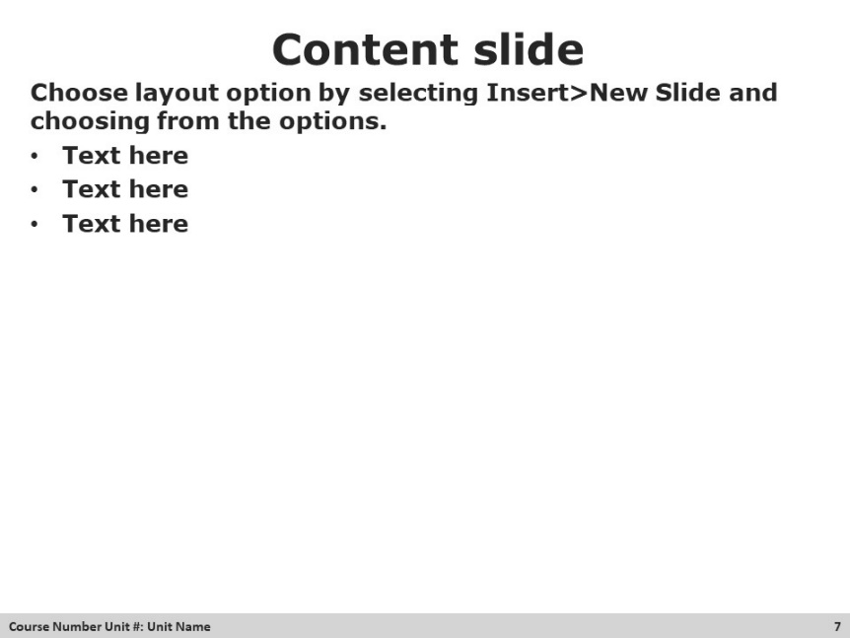

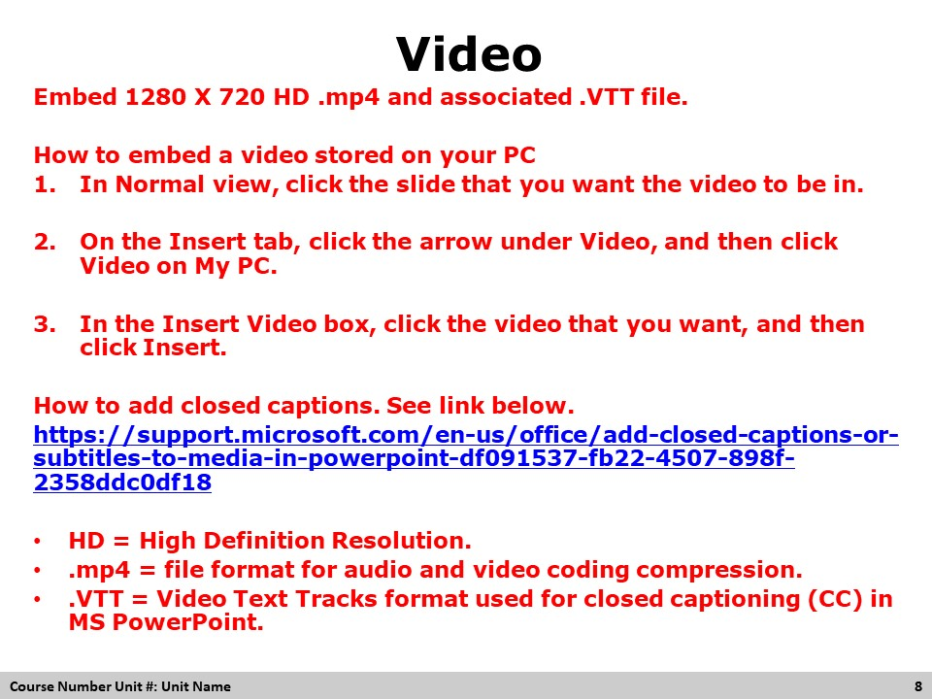
Pre-Video Discussion
- This needs to be included in each video to describe the topic of the video.
- <LINK>
Play Video
Title Video Title
Summary Brief description of the video
Time (hh:mm)
Audio or No Audio
Post-Video Discussion
- This needs to be included in each video to describe what was learned from the video.

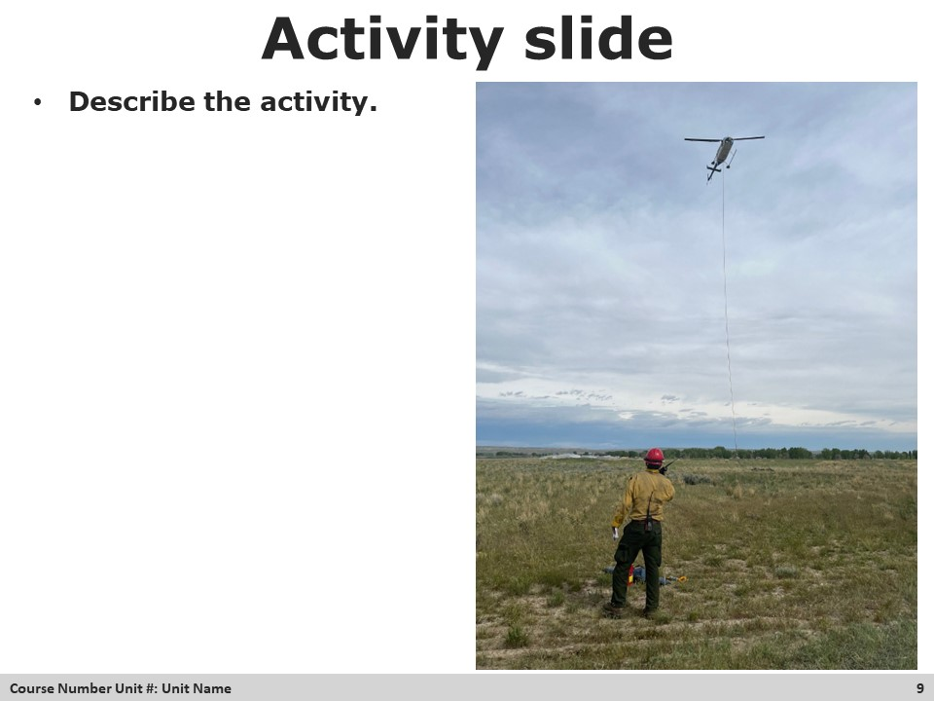
Activity – Make sure activity information is in the student activity packet if needed.
Purpose: Write the purpose of the exercise.
Materials: List of materials that are needed for this unit. Make sure they are also in the materials list for the unit.
Length: Time in minutes.

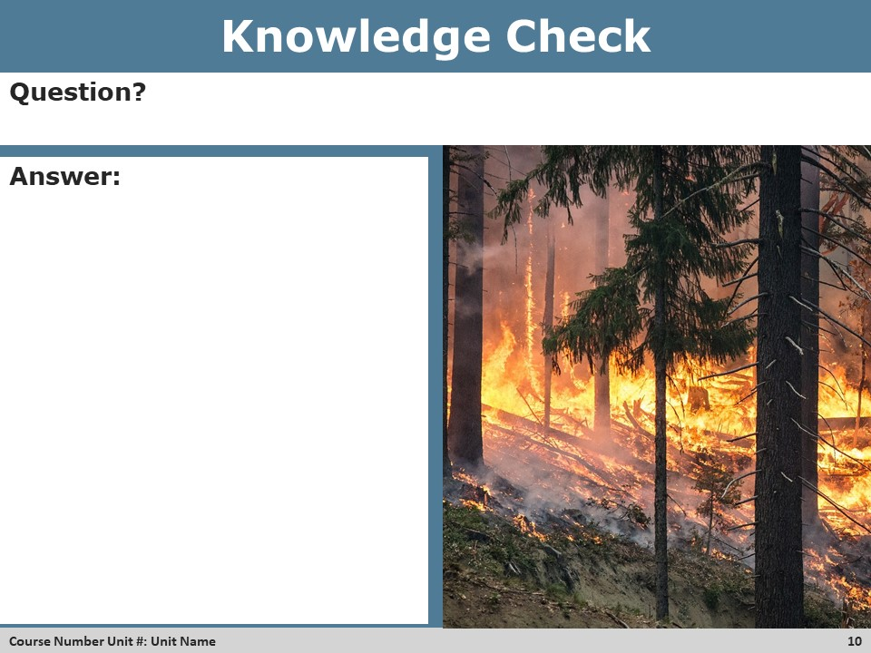
Activity
Purpose: Write the purpose of the exercise.
Length: Time in minutes.
Materials: List of materials that are needed for this unit.

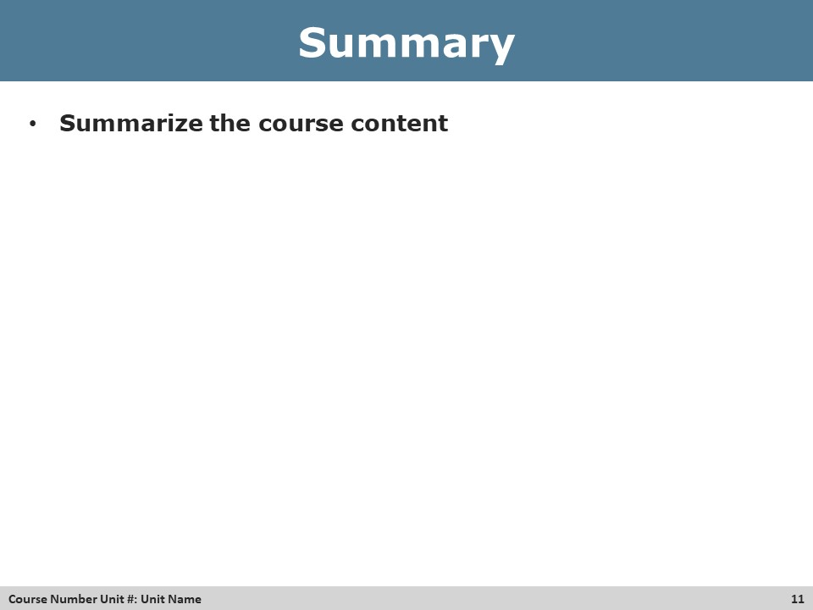
Summary
EXAMPLE Summary: This unit will focus on how the MEDL should prepare for responding to an incident and how to check in when they first arrive.

