A publication of the
National Wildfire
Coordinating Group

NWCG Standards for Airtanker Base Operations –
Appendices

PMS 508a MAY 2024

Table of Contents

Appendix A: Airtanker Base Operations Plan (Single Engine Air Tanker [SEAT] or Temporary Base) 1
Appendix B: Mobile Retardant Bases (MRBs) 13
General 13
Ordering 13
Operations 13
Appendix C: Recommended Outline for a Local Airtanker Base Operations Plan (ABOP) 14
Chapter 01 – Introduction 14
Chapter 02 – Personnel 14
Chapter 03 – Airtanker Base Equipment and Facilities 14
Chapter 04 – Communications 15
Chapter 05 – Logistics 15
Chapter 06 – Dispatch Procedures 15
Chapter 07 – Operations 15
Chapter 08 – Safety 17
Chapter 09 – Administration 18
Chapter 10 – Environmental Considerations 18
Chapter 11 – Security 18
Appendix D: Aircrew Briefing and Orientation Outline 19
Appendix E: Hot Loading Plan Template 21
Purpose 22
Authority 22
Distribution 22
Hazard Assessment 22
Required Training 22
Roles and Responsibilities 22
Operational Procedures 23
Safety Equipment 24
Aircraft Rescue Firefighting (ARFF) Equipment 24
Pump System 24
Communications 24
Authorized Personnel 25
Appendix F: Simultaneous Fueling and Loading Plan Template 27
Purpose 28
Authority 28
Distribution 28
Risk Assessment 28
Required Training 28
Roles and Responsibilities 28
Operational Procedures 29
Safety Equipment 30
Firefighting Limitations/Emergency Operations 30
Authorized Personnel 30
Refueling Operations 30
Appendix G: Standard Hand Signals for Airtanker Base Operations 33
Appendix H: Additional Positions 47
Fixed Wing Base Manager (FWBM) 47
MAFFS Airtanker Base Manager (MABM) 47
MAFFS Airtanker Base Specialist (MABS) 48
MAFFS Liaison Officer (MAFF) 49
Field SEAT Coordinator (SECO) 49
Appendix I: Staffing Matrix 51
Minimum Staffing Levels Required for Operations 51
Appendix J: Suggested Minimum Equipment at an Airtanker Base 53
Appendix K: Daily Operational Briefing Materials 55
Appendix L: Daily Risk Assessment 56
General 56
Appendix M: Airtanker Base Readiness Review 58
Introduction 58
Purpose 58
Applicability 58
Responsibility 58
Section A: General 60
Section A: General (continued) 61
Section B: Base Facilities and Communications 63
Section C: Planning and Administration 65
Section D: Ramp Operations 68
Section E: Retardant Operations 71
Section F: Personnel 72
Section G: Safety and Security 73
Section H: Summary 74
Section I: Evaluators’ Signatures 75
Appendix N: Recommended Reference Library 76
Appendix O: Administration Forms and Reports 78
Introduction 78
Applicability 78

Appendix A: Airtanker Base Operations Plan
(Single Engine Airtanker [SEAT] or Temporary Base)
ATB/SEAT Base name:
Location:
Agency:
Region/State:
RAO/SAM:
Contact #:
Forest/Unit:
Aviation Officer:
Contact #:
Dispatch center:
Contact #:
General Airport Information
Airport name: | FAA identifier: |  |  | Lat: N
 |  |  |  | Long: W
Elevation: | Type of airspace: |  |  | Unicom frequency:
Runway length: | Runway width:
Directions to airport: Provide driving directions to the airport:
Airport Manager: |  |  | Fuel: [ ] Jet-A [ ] Av-Gas  Amount on-site: Amount on-site:
 |  |  | Office phone:
Primary person designated as a contact for the Tanker Base operation:
[] Airport Manager [] Other:
Agreements: List any agreements or MOUs that are in place for the Tanker Base operations:
[] No agreements [] Verbal agreement [] Formal written agreement [] Formal written MOU
[] Other:
Security: Describe the type of security the airport has (e.g., locked gates, fences, security cards, etc.):
Airport access: Describe any concerns or procedures for accessing the airport:
Comments: Provide a brief narrative about any special concerns for operating at the airport:
Airport Fueling
Describe the procedures established for ordering fuel on the base:
General response time for fuel truck:
[] < 15 min [] < 30 min [] > 30 min [] Other:
Does the airport allow hot refueling operations for SEATs? [] Yes [] No
Does the airport have a designated area for hot refueling? [] Yes [] No
Location of the designated area:
Comments on fueling:
Describe the jettison area established for the base:
Lat: Long:
Describe notification process after jettison occurs:
Descriptive area:

Dispatch Information
Dispatch call sign: |  | Office phone:  Office fax/ email:  Aviation Dispatcher:
Aviation frequencies monitored by the dispatch office:
[] National Flight Following [] Air Guard [] Unicom [] Ramp
[] Other:
Agency frequencies monitored by the dispatch office:
[] USFS [] BLM [] BIA [] NPS [] FWS [] State [] Other:
Flight following requirements:
[] AFF [] Agency flight following with 15 min check-ins [] Combination AFF/agency
[] Other:
Primary flight following frequency: Provide the frequency used to flight follow from the base:
RX: | TX: |  | Tone:
Name of flight following frequency listed above:
[] National Flight Follow [] Other:
Initial check-in information: (List information required for the pilot to provide the dispatcher on initial contact.)
[] T-Number [] Amount of fuel [] Mission objective [] General heading [] ETA to incident
[] Other:
15-minute check-in requirements: (Describe procedures established for 15-minute check-ins.)
[] Dispatcher monitors AFF only, no verbal contact with pilot.
[] Dispatch monitors AFF, verbal “ops normal” with pilot.
[] Dispatch requires 15 min verbal check-ins (Current location, bearing, operational status report).
[] Other:
Dispatch closeout requirements: (Check all the procedures that apply when landing at the airport.)
[] Call dispatch when 5 miles out of landing at the airport or when entering sterile cockpit environment.
[] Call dispatch when the pilot is on the ground at the airport.
[] Call dispatch when the pilot is in the pit.
[] Other:
Comments on flight following: (Provide a brief narrative about any special concerns for flight following.)

Ordering General Supplies and Equipment
Placing orders: (Identify the primary source the ATBM/SEMG should use to order their supplies/equipment from.)
[] Unit Aviation Manager [] Dispatch Office
[] Other:
Documenting orders: (Describe how the ATBM/SEMG should document their request for supply / equipment orders.)
[] Use General Message Form [] Verbal Request Only
[] Other:
Inventory procedures: (Describe how the ATBM/SEMG should keep track of their supply and equipment orders.)
[] Local Inventory Form
[] Other:
Base Facilities
Base facilities are identified as: (Check the one that best describes the base facilities.)
[] Mobile Retardant Base [] Temporary/portable airtanker base
Base facilities contain the following: (Provide as much detail as possible in the comments.)
Item | Yes |  | No | Comments
Outside shade
Indoor office space
Electricity
Water
Indoor restrooms
Portable toilets
Kitchen area
Sleeping area
Outside lights
Garbage services
Storage area
Other amenities: (List any amenities like microwave, showers, TV, etc.)
Office equipment available at the base:
[] Copier [] Computer [] Internet Access [] Printer [] Fax Machine [] Telephone (landline)
[] Other:
Types of radios available at the base:
[] VHF-AM Base Station [] VHF-AM Vehicle Radio [] VHF-AM Handheld Radio
[] VHF-FM Base Station [] VHF-FM Vehicle Radio [] VHF-FM Handheld Radio
Other:

Vehicle Parking
Area designated for parking at the base: (Describe area designated for parking at the Base facilities.)
Overflow parking area: (Describe the area designated for overflow parking.)
Base Facility Security
(Describe the general security measures established for the base like fencing, locked gates, security cards, etc.)
Municipal police department, with regular patrols.
Is the base facility locked up during the night? [] Yes [] No
Are the managers issued a key? [] Yes [] No
Comments:
Are the contractors issued a key? [] Yes [] No
Comments:
Primary person responsible for locking up the base facilities:
Primary person responsible for opening up the base facilities:
Comment on the base facilities:
Ramp Operations
Number of pits: |  | Tie downs in the pit area: [] Yes [] No
Max number of airtankers the base can load: |  | Tie down availability outside the ramp space: (Check one)
 |  | [] No Tie Downs | [] Limited Tie Downs | [] Tie Downs Available
Largest airtanker that base can support? (i.e., MAFFS, DC-10, BAE-146 etc.)
Wingtip clearance to nearest fixed object or hazard over 3 ft high. _______________
Does this meet national minimum wingtip separation standards? [] Yes [] No
Aircraft overflow staging or parking area: (Describe the area used to stage airtankers/SEATs out of the pit area)
Does this area meet national minimum wingtip separation standards? [] Yes [] No
Comments:
Vehicle access on ramp: [] No vehicle allowed [] Support vehicles only [] ATBM/SEMG vehicle upon request
[] Other vehicles:
Ramp vehicle ingress/egress routes: (Describe the procedures for a vehicle to access the ramp)

Ramp Personnel
Recommended number of personnel needed to run base safely and efficiently:
____SEMGs ____RAMPs ____FWPTs ____MXMS ____RTCMs ____ATIMs ____
Contractor Loaders ____ Agency Loaders ____
[] Other:
Authorized personnel allowed to load aircraft:
[] Contractor personnel only [] Qualified agency personnel
[] Other:
Specialized loading program established for the base: [] Yes [] No
(If yes, describe the program or type of qualifications loader need to work at the base.)
Is the base approved for simultaneous loading and fueling of LATs?: [] Yes [] No
(If Yes, signed copy of supplement must be attached and approved by Regional Aviation Officer/State Aviation Manager.)
Is the base approved for hot loading LATs?: [] Yes [] No
(If Yes, signed copy of supplement must be attached and approved by Regional Aviation Officer/State Aviation Manager.)
Personal Protective Equipment (PPE) Required for Ramp
Dress code for agency personnel:  [] Long pants [] Shorts authorized  [] Boots [] Closed toe shoes  [] Other: |  | Dress code for contractor personnel:  [] Long pants [] Shorts authorized  [] Boots [] Closed toe shoes  [] Other:
PPE requirements for agency personnel:  [] Eye protection [] Hearing protection  [] Other: |  | PPE requirements for contractor personnel:  [] Eye protection [] Hearing protection  [] Other:
Vest requirements for agency personnel: |  | Vest requirements for contractor personnel:
Color | Position (SEMG, RTCM, RAMP, FWPT, etc.) | Color | Position (MXMS, RTCM)
Green/Hi Vis |  | Blue
Orange/Hi Vis
[] No vest requirements for agency personnel |  | [] No vest requirements for contractor personnel

Environmental Considerations
Wash down equipment:  [] No wash down area  [] Regular faucet/garden hose  [] Pressurized washer | Containment pit or area:  [] Established containment pit  [] Temporary containment pit/area  [] No containment pit |  | Safety equipment on Ramp:  [] Eye wash station  [] First aid kit  [] Fire extinguisher  [] E-Vac kits  [] Other
Wash down area: (Describe) | Ramp/pit drainage: (Describe)
Describe spill/effluent/wash-water mitigation and contact or notification information:
Designated maintenance or shut down area:
Pit Access
Established procedures for airtankers entering the pit:  (Describe the type of authorization that allows the pilot to enter the pit area.) |  | Established procedures for airtankers departing the pit:  (Describe the type of authorization that allows the pilot to exit the pit area.)
Ramp Communications
Ramp frequency:  [] VHF-AM  [] Other: | Radio equipment used on Ramp:  [] VHF-AM Radios [] VHF-FM Radios  [] Other:
Headsets required on Ramp: [] Yes [] No
If Yes, what frequency is monitored: [] VHF-AM [] Other:
Flight Launch Rotation
Describe the flight rotation procedures established for the base (consistent with National Rotation Policy): (Who is up first for a dispatch?)

Water System
Water supply lines: (Check the ones that apply to the water supply system.)
[] Underground Plumbed Water Lines [] Surface Water Supply Lines [] Hose lay
[] Other
Water metering system in place for the base: [] Yes [] No
If yes, describe the procedures:
Water valve system: (Provide as much detail as possible in the comments.)
Type of valve | Yes | No | Location/Comments
Primary shut off valve
Additional shut off valve
Additional shut off valve
Other miscellaneous valves:
Comments on the water system:
Water Supply
Primary water source: (Describe the primary water source used by the base.) |  |  |  | Capacity:
Water ordering procedures: (Describe the procedures established for ordering water.)
Trigger point for re-ordering water: (Describe when you should notify the unit to resupply the water source.)
Timeline for re-supplying water: (Document the estimated time frame for re-supplying water.)
[] Immediate [] 1-2 Hours [] 2-3 Hours [] Other: N/A
Back-up water source: (Describe any back-up water sources available for the base.)

Wildland Fire Chemical (WFC) System
WFC supplier: (Check One) [] Full-Service Contract [] Agency Supplies WFC
[] Other:
WFC pumping system: (Check the best one that applies to the base set up.)
[] Fully service contract that mixes the water and WFC and loads the aircraft as part of the contract.
[] Water and WFC directly supplied to the vendor support vehicle, mixed, and loaded on aircraft.
[] Water and WFC directly supplied to ground mixing tank, mixed, and loaded on the aircraft.
[] Other:
WFC refractometer readings: (Describe how refractometer readings are taken during the mixing process.)

WFC pumps: [] Agency Owned [] SEAT Contractor [] Full-Service Contract Equipment
[] Other:
How many primary pumps does the base have?  [] 1 [] 2 [] 3 [] 4 |  | Back-up pumps available:  [] Yes [] No ____ How many?
WFC pump maintenance: Who is responsible for supplying fuel, oil, gaskets, etc. for the pumps?
[] Agency Personnel [] SEAT Contractor [] Full-Service Contractors
[] Other
WFC pump maintenance: Who is responsible for maintaining the pumps?
[] Agency Personnel [] SEAT Contractor [] Full-Service Contractors
[] Other
WFC Supply
Type of WFC Used |  |  | Type of Foam Used | Type of Gel Used
Liquid: | Powder:  N/A |  | N/A | N/A
Mix Ratio:  Refractometer: | Mix Ratio:  Refractometer: |  | Mix Ratio: | Mix Ratio:  Marsh Funnel Time:
Re-Order Trigger Point: | Re-Order Trigger Point: |  | Re-Order Trigger Point: | Re-Order Trigger Point:
Ordering WFCs: (Describe the procedures established for ordering WFCs.)

Timeline for re-supplying WFCs: (Document the estimated time frame for re-supplying WFCs.)
[] < 12 Hours [] < 24 Hours [] < 36 Hours [] < 48 Hours [] Other: 72 hours

WFC Storage Tanks
Number of storage tanks at the base: |  | Maximum gallons of liquid WFC :
WFC Re-Circulation Procedures
WFC re-circulation schedule :  [] Daily [] Every 2-3 Days [] Weekly  [] Other |  | Length of time designated for re-circulation:  [] 30 min. [] 1 Hour [] 2 Hours [] 3 Hours  [] Other
Primary person designated to re-circulate the WFC:
Does the base have a Stormwater Pollution Prevention Plan (SWPPP)? [] Yes [] No
Primary Contact for the SWPPP:
Hazardous material and WFC spill response plan in place? [] Yes [] No
What type of additional best management practices (BMPs) are in place?
Primary point of contact for HAZ Mat and spills:
Comments on WFC System
Initial Briefings
Primary person designated to provide the initial briefing to incoming pilots:
[] Unit Aviation Manager/FAO [] Base Manager [] Other:
Check what elements are given to the pilot on their initial briefing:
[] Local Briefing Packet [] Maps [] Frequency Lists [] Repeater Locations [] Organizational Chart
[] Other:
Primary person designated to provide the initial briefing to incoming ATBM/SEMG:
[] Unit Aviation Manager/FAO [] Base Manager [] FMO
[] Other:
Check what elements are given to the base manager on their initial briefing:
[] Local Briefing Packet [] Maps [] Frequency Lists [] Repeater Locations [] Organizational Chart
[] Other:
Type of known aerial hazard map available at the base: (Describe what the base is using for their aerial hazard map.)
Daily Morning Operations
Primary person designated to give the morning briefing.
[] Unit Aviation Manager/FAO [] Base Manager [] Other:
Primary source of intel for the base:
[] Intel directly available at the base [] Dispatch faxes intel to base [] Intel brought out to the base
[]Other:
General time frame for morning briefings:
Check the items that are reviewed during the morning briefing:
[] National Sit Report [] GACC Sit Report [] Local Sit Report [] Weather [] Lightning Map
[] ERC/BI [] Aviation Resource Report [] Fire Status [] Frequencies [] Airspace
[] Other:
Pilots required to do morning radio check:  [] Yes [] No |  | If yes, who do they perform their radio check with?
Loaders required to do morning radio check:  [] Yes [] No |  | If yes, who do they perform their radio check with?
Base Manager required to perform a morning check-in?  [] Yes [] No |  | If yes, who do they contact?
Lunch scheduling low fire activity: (Describe scheduling lunch breaks during periods of low fire activity.)
[] Contractors remain at base [] Contractors depart base [] Contractors stagger or rotate for coverage
[] Other:
Lunch scheduling high fire activity: (Describe scheduling lunch breaks during periods of high fire activity.)
[] Contractors remain at base [] Contractors depart base [] Contractors stagger or rotate for coverage
[] Other:
Lunch scheduling during an ongoing fire: (Describe scheduling lunch breaks during periods of high fire activity.)
[] Agency provides contractors lunch [] Contractors stagger or rotate for coverage
[] Other:
Daily Evening Operations
Evening meals provide at the base: [] Yes [] No
If Yes, describe the trigger point for providing an evening meal to contractors:
Evening debrief: (Describe the general base policy for conducting end of day de-briefing sessions.)
[] Always conducted each day [] Conducted next day in AM briefing
Primary person designated to give the evening debriefing?
[] Unit Aviation Manager/FAO [] Base Manager [] Other:
Who is responsible for providing base personnel with the duty day shut down time and next day on time:
[] Dispatch [] Base Manager [] FMO [] Unit Aviation Manager/FAO
[] Other:
Procedures Established For Ordering Airtankers
An order to mobilize an airtanker will be received from the following source:
[] Dispatch Office [] Unit Aviation Manager/FAO [] Base Manager [] FMO
[] Other:
The order will be sent to the base by the following method: [] Fax [] Landline [] Cell Phone [] Radio
[] Other:
The order will be documented on the following form when dispatched from the base:
[] Aircraft Dispatch Form [] Local Aircraft Dispatch Form [] ATB-3 [] Resource Order

The order to mobilize an airtanker will be given to the following person:
[] Unit Aviation Manager/FAO [] Base Manager [] Other:
Type of documentation a pilot will receive to mobilize for an order:
[] Copy of the Aircraft Dispatch Form [] Verbal Notification [] Other:
Types of record keeping required at the base: (List the documents that the unit requires copies of for the system of records keeping.)
[] Inspection Sheets [] Tanker Logs [] Cost Summary Sheets [] OAS 23s
[] Other:

Administration-SEATs
Billee Codes for the Area of Operation
Agency | Unit Name | Billee Code |  | Agency | Unit Name | Billee Code
BLM |  |  |  | FWS
USFS |  |  |  | STATE
BIA
NPS

Charge Codes:
Obtaining Charge Code Information: (Describe how the manager obtains their charges codes each day for the OAS 23.)

Who is designated to receive copies of all the documentation generated at the base: (Name of agency personnel)
What is the timeframe for providing the agency with the copies of the required documentation:
[] Daily [] Every week [] Every 2 weeks [] At the end of your assignment
[] Other:

Crash-Rescue Operations
Airport Fire Department: |  |  | # of ARFF units: | Capacity of units:
Staffing:
Nearest Hospital: |  |  | Lat: | Long:
Reporting Accident/Incidents On The Base
Date: | Time: | Reported by:
INCIDENT INFORMATION
What type of incident observed or reported?
Who/What is involved?
EMERGENCY MEDICAL SUPPORT (EMS)
What Type of EMS is required?
Injuries?  Yes  No  Unknown
STEP ONE: Try to document as much of the information possible on the table above from your observations or the individual that is reporting the incident.
STEP TWO:
DIAL: 911 TO REPORT THE INCIDENT AND REQUEST ASSISTANCE.

Time Notified:
STEP THREE: Notify the appropriate Initial Attack Dispatch Office and relay the known information so they can activate their Aviation Mishap Response Plan.
Dispatch Office: _________________________________Phone:________________________

Time Notified:
STEP FOUR: Establish who is the on-scene Incident Commander (IC) and who are the on-scene Incident Responders. Appoint a main contact on-site for the dispatch office to call for further information or instructions. Relay the names and titles to dispatch.
On-scene IC: _____________________________________Phone:____________________________
On-scene Responder: ____________________________________________________________
Main Contact: _________________________________Phone:____________________________

NOTE: Be prepared to provide the dispatch office with the following information:

Make/Model of Aircraft:______________________ N#:___________ Call Sign:__________
Type of Fuel: Jet-A:____ AV-GAS:_____ AMOUNT:____________
Pilot Name:___________________ Driver:___________________ Loader:_______________________
Make/Model of Fuel Truck: ____________License #________________Amount of Fuel:___________

Appendix B: Mobile Retardant Bases (MRBs)

General
Contractor operated and maintained MRBs for mixing and loading United States Forest Service (USFS) qualified retardant types as listed on the USFS Qualified Products List (QPL) can be ordered to support SEAT, large airtanker, and Very Large Airtanker (VLAT) operations as desired.
When ordering a mobile retardant base, consider factors such as the types of airtankers the base will service and the type of retardant product needed. Questions regarding the qualified and approved retardant types may be directed to the National Technology and Development Center: (406) 329-3900.

Ordering
Individuals Authorized to Order Under the Contract.
• Dispatchers–National Interagency Coordination Center, Geographic Area Coordination Centers, or local dispatchers via Resources Orders.
• Contracting Officers from the US Forest Service and Department of the Interior with adequate Certificate of Appointment to cover the value of the order via task orders.
• Contracting Officers from other Federal Agencies with adequate Certificate of Appointments or warrants to cover the value of the order via the issuance of task orders. Orders received by the contractor from agencies other than the US Forest Service and the Department of the Interior, must be submitted to and approved by the US Forest Service Contracting Officer before the contractor’s acceptance of the order.
An agency Airtanker Base Manager/Agency Representative should be assigned to each mobile operation. Airtanker Base Manager/Agency Representative, is responsible for contract administration functions such as:
a. Ensuring Lot Acceptance, Quality Assurance (LAQA) functions are performed according to Guide to Preventing Aquatic Invasive Species Transport by Wildland Fire Operations, PMS 444, https://www.nwcg.gov/publications/pms444; and Lot Acceptance, Quality Assurance, and Field Quality Control for Fire Retardant Chemicals.
b. Verifying receipt of retardant quantities and maintaining agency records.
c. Communicating any safety and environmental concerns with the contractor that includes compliance with Occupational Safety and Health Administration (OSHA) and Environmental Protection Agency (EPA) regulations.

Operations
When utilizing a MRB for any type or size of airtanker, the same policies and procedures from the NWCG Standards for Airtanker Base Operations (SABO), PMS 508 must be adhered to. This includes developing a local ABOP, personnel, qualifications, staffing, and safety requirements.

Appendix C: Recommended Outline for a Local Airtanker Base Operations Plan (ABOP)
The following outline is recommended to develop the required ABOP.

Chapter 01 – Introduction
A. Objectives
B. Authority
C. Revisions/Updates
D. General information
1. State/Regional organization
2. Airtanker base location in State/Region
3. Air tactical organization
4. Fuels and fire behavior common to area
5. Prominent landmarks in area
6. Local area orientation flight
7. Local airfield management

Chapter 02 – Personnel
A. Agency (or Interagency) responsibilities
B. Airtanker base personnel
1. Organization chart
2. Local roles and responsibilities
3. Staffing levels
4. Plan for expanding complexity
C. Airtanker base-specific training
1. Local training
2. Training documentation

Chapter 03 – Airtanker Base Equipment and Facilities
A. Equipment
1. Equipment at the base
a. Parts and equipment storage
b. Maintenance responsibility
c. Ramp vehicles, forklift, and fueling
2. Base/Ramp/Dispatch communications equipment
3. Lighting equipment
4. Electrical system
B. Facilities
1. Airtanker base facilities
2. Aircrew standby facilities
3. Layout of the base and ramp
4. Vehicle parking plan

Chapter 04 – Communications
- Communications plan
- Phone lists
- Flight following frequencies
- Tactical frequencies
- Base/ramp frequency
- Dispatch frequencies
- Airport frequencies

Chapter 05 – Logistics
- Aircrew accommodations
- Transportation and lodging
- Food and drink

Chapter 06 – Dispatch Procedures
- Briefings on base dispatching procedures
- Notifications for dispatches
- Flight following procedures
- Jettison area
- Retardant Avoidance Areas
- Briefing and orientation
- Geographic area and local dispatch organization
- Zones of influence

Chapter 07 – Operations
- General
- Safety briefings
- Local ramp procedures and safety considerations
- Aircraft parking (loading, day-off, maintenance etc.)
- Run-up area
- Wash down area
- Foreign object debris (FOD) abatement
- Pit configuration in regard to LAT, SEAT, VLAT etc.
- Local pit and ramp hazards
- Light fixed-wing parking and ramp procedures
- Low visibility ramp operations
- Vehicles on the ramp
- Visitors on the ramp
- Retardant operations
- Types of retardant available
- Retardant loading and metering
- Retardant offloading and reloading
- Pumping equipment (diagram)
- Maintenance responsibility and requirements
- Fueling
- Local vendor(s) with contact information and services available
- Fixed-Wing Parking Tender (FWPT) procedures
- Procedures for specific tactical aircraft
- SEAT
- Light Fixed-Wing
- Helitanker
- Smokejumper
- MAFFS
- VLAT
- Fixed-Wing Base Operations
- Personnel Transport
- Cargo
- IR

Chapter 08 – Safety
A. OSHA compliance
1. Retardant mix plant and equipment
2. All agency owned, leased, or rented facilities
B. Airtanker base self-evaluations
1. Elements and schedule
a. Unit inspections
b. Airport inspections
c. Regional reviews
d. Others (base-specific)
C. Aerial hazard map
1. Responsibility and procedures for update
2. Briefings on airport hazards
3. Turbulence, wind, and time of day limitations on flight activity
D. Temporary flight restrictions/military training routes
1. Local procedures
2. Map
E. Emergency response planning and equipment
1. Emergency response plan
2. Location of emergency response equipment
3. ARFF capability and contact/ordering procedures
F. Hazard, Incident, and Accident reporting
1. Agency required system
2. Responsibilities
G. Hearing Conservation
1. Local policy and procedures
H. Dropping on or near congested areas
1. Local Procedures
I. Base safety items
1. Inventory
2. Maintenance responsibility
J. Severe Weather (thunderstorms, hailstorms, strong winds, tornados, hurricane, haboob, etc.)
1. Aircraft Plan
2. Facility Plan

Chapter 09 – Administration
A. Forms and reports
B. Incident cost reporting
C. Contract administration
1. Aircraft contracting organization with contact information
2. Retardant contract
a. Responsibility and procedures
3. Aircraft payment procedures
a. Verification of flight times
b. Schedule for submission of flight use reports
c. Payment of landing fees and airport use costs
4. Availability and standby requirements
a. Pilot standby/availability hours
b. Off-duty scheduling and means of contact
D. Facilities
1. Lease Agreements
2. Overweight Waivers/Agreements
3. Maintenance scheduling
4. Liquidated damages
5. Local airfield management
a. Regulations
b. Procedures

Chapter 10 – Environmental Considerations
- Wildland Fire Chemicals Dropping in Sensitive Areas
- Wash down, Spill and Waste Management Systems
- Containment and cleanup procedures and available equipment
- Notifications and contacts

Chapter 11 – Security
- Security planning per agency guidelines
- Aircraft Security

Appendix D: Aircrew Briefing and Orientation Outline
It is the base manager’s responsibility to provide information regarding planned use, and above all, a comprehensive safety briefing to begin each day. Equally important is debriefing the day’s activities to identify any safety concerns that may have developed through the operational period and to review what is and is not working operationally.
The person responsible for conducting these briefings and debriefings shall be clearly identified by position and relationship to the operation. Aviation risk assessments will be completed as appropriate and reviewed with affected personnel.
Any briefing must be documented. Documentation should include the facilitator’s name, attendee’s printed name and signature, date, and topics discussed.
The SABO requires that each local ABOP include a Pilot Briefing and Orientation that can be handed to and discussed with aircrews.
This is an outline that discusses the areas of operation and safety. The outline should be briefed to all flight crews upon their arrival at the base. A briefing package should be provided to all flight crews. This information may include:
Noise abatement procedures as they pertain to each particular base, contacts, frequency maps, charts, and lists for all local cooperators.
A. Local area orientation
1. Prominent local landmarks
2. Local dispatch organizations and locations
3. Geographic area dispatch organization and procedures
4. Zones of influence
5. Jettison area
6. Fuels and fire behavior common to the area with weather zone information
B. Communications
1. Local communications
a. Communications system map to include simplex and repeaters
b. Frequencies, call signs, and identifiers
c. Aerial communications and communication procedures
d. Airfield and airtanker base communications
e. Incident communication plan (as applicable)

C. Airspace
1 Current Class B Chart if applicable
2. If military co-located, local procedures, discuss with local military units
3. Known aerial hazards
D. Dispatching procedures
1. Use of the Aircraft Dispatch Form
2. Verification of flight times
3. Schedule for submission of flight use reports
4. Local dispatch procedures from initial report to dispatch of aircraft
5. Flight following, check-in requirements
E. Contract administration
1. Pilot standby and availability hours, off-duty scheduling, and means of contact
2. Flight times, extended hours
3. Unavailability for failure to meet contract requirements
4. Maintenance scheduling
5. Meal policy
F. Base operations
1. Type of retardant in use
2. Loading/pumping equipment capabilities
3. Aircraft parking locations and procedures
4. Airport hazards: ramps, runway, approach, and departure
5. Safe engine operations (run-up procedures and locations)
6. Mission currency requirements
7. Weather, time of day limitations for flight activities, or military operations (if collocated)
8. Flight plans, including check-in requirements
9. Crash-Rescue Plan
a. Emergency procedures
b. Emergency field and crash-rescue equipment
10. ASM/lead plane procedures and other operations
11. Any other item that is specific to the base and its operations

Appendix E: Hot Loading Plan Template
Click or tap here to enter text. AIRTANKER BASE HOT LOADING PLAN

Prepared by: Date
Base Manager

Reviewed by: Date
Forest Aviation Officer/Unit Aviation Manager

Approved by: Date
Regional Aviation Officer/State Aviation Manager

Purpose
This Operations Plan is prepared to conduct hot loading procedures safely and efficiently as specified by the SABO. The plan incorporates hot loading procedures as specified in the SABO.

Authority
All airtanker operations will be conducted within the guidelines as established by the SABO, contracts, and established aircraft, and base operational plans.

Distribution
A copy of this plan will be provided to all airtanker base and retardant personnel at the beginning of each season. In addition, a copy of this plan should be made available to aviation managers and cooperators as requested.

Hazard Assessment
A Risk Management Worksheet or Job Hazard Analysis (JHA) or equivalent for conducting hot loading operations must be completed and reviewed by all airtanker base and retardant personnel before operations.

Required Training
Personnel considered qualified in hot loading operations will have successfully completed and reviewed the required training and materials listed below. The following information will be included within the course of instruction offered to all personnel before conducting hot loading operations:
- Review of the SABO Hot Loading Procedures.
- Working knowledge of the standard FWPT hand signals.
- Thorough training of ramp operations with personnel before performing independently under actual operational conditions.
- Click or tap here to enter text.
- Click or tap here to enter text.
All training will be documented and placed in the personnel training folders.

Roles and Responsibilities

Airtanker Base Manager (ATBM)/SEAT Base Manager (SEMG)
The base manager is responsible for authorizing hot loading operations. Provides overall safety oversight and ensures the initial shutdown and briefing is conducted before hot loading. The base manager is responsible for training base personnel on hot loading procedures and this plan and ensures hot loading procedures are adhered to.

Ramp Manager (RAMP)
The RAMP is responsible for ensuring that trained personnel are designated to monitor communications, loading operations, and movement of aircraft. RAMP will coordinate with the SEMG to ensure that hot loading procedures for SEATs are in compliance with established guidelines and procedures and mitigate any problems or concerns that may occur.

Fixed-Wing Parking Tender (FWPT)
The FWPT is responsible to monitor the hot loading procedures throughout the entire operation. The FWPT must maintain eye contact with the Pilot in Command (PIC) as well as be able to see all running engines and the loading crew. The FWPT will cease operations when there are unintended spills, unauthorized personnel on the ramp or observes personnel approaching running engines.

Retardant Crewmembers (RTCM)
RTCMs are responsible for observing and following the FWPT hand signals, loading the airtanker safely and efficiently while avoiding the hazardous areas of the running engine(s).

SEAT Support Personnel
Support personnel may be required to provide additional support when the SEAT is in the pit (cleaning windshields, etc.) and will do so only with permission from the RAMP and direction of the FWPT. The SEAT support personnel can assist with loading when authorized by the ATBM or SEMG.

Operational Procedures

Receiving Aircraft for Loading
1. The pilot will establish contact with RAMP or FWPT by radio and request to hot load.
2. The aircraft will be directed to the appropriate loading pit.

Initial Arrival
The first specific type of airtanker arriving at the base each season shall shut down all engines before hot loading at an airtanker base. The flight crew will brief base personnel on procedures and equipment and will explain loading limitations specific to that aircraft type.
Additional instructions for SEAT aircraft are as follows:
- Review of the general operating procedures for the base and the specific procedures established for hot loading SEATs.
- Review the role of the SEMG and SEAT support personnel while operating at the base and during the hot loading procedures.
- Confirm the pump loading capacity gallons per minute (GPMs) with the pilot and SEAT Support Personnel.
- Consider setting up a separate area for SEATs only when operating from a LAT base during periods of high activity.

Loading
After the initial shutdown and briefing, that specific type of airtanker may participate in hot loading operations. Upon reaching the pit, pilots will reduce engine revolutions per minute (RPM) to “ground idle” and shut down engines on the loading side. When the pilot has the aircraft secured, they will inform the FWPT via radio and/or hand signal with the load amount requested and that they are clear to load.
FWPT, after visually checking the area, will signal the RTCMs with the load amount requested, and after confirmation of the load amount will give the signal to approach and hook up to begin loading. The FWPT will remain positioned to allow a clear view of the RTCMs, pilot, and running engines at all times during loading.
The RTCMs will approach and depart the aircraft only within the “Safe” area behind the trailing edge of the wing. Most hot loading operations will be conducted in this designated safety area. The MD 87 and DC-10 have loading ports in front of the wing, therefore RTCMs may remain in front of the leading edge of the wing. RTCMs will remain a safe distance from the wing at all times. RTCMs will never go on the side of the fuselage with the running engines.

Releasing the Aircraft
After loading has been completed the RTCMs will disconnect the hose and move to the safe area, away from prop blast, at which point the FWPT will determine if it is clear to release the aircraft to taxi. During the entire sequence, the pilot will remain in radio communication with the RAMP or FWPT who will signal to the aircraft when to exit the pit and taxi out.

Safety Equipment
The required Personal Protective Equipment (PPE) listed in the SABO will be provided and shall be used during ramp operations. Required fire extinguishers will be provided at each loading pit.

Aircraft Rescue Firefighting (ARFF) Equipment
Base personnel may assist in emergency operations only where their capabilities, equipment, training, and PPE are not exceeded. In all cases, firefighting resources, or standby ARFF equipment will be dispatched when the threat or presence of fire is detected.

Pump System
Most airtankers are loaded at 450 GPMs. SEATs need to be loaded at a slower rate (generally 250 GPM). The RTCMs will load all airtankers at their appropriate rates and will be trained to load the SEATs at the reduced rate.

Communications
Aircraft will remain in communication with designated ramp personnel throughout the hot loading operation. If communications are unable to be established and maintained, the hot loading operation will be discontinued until positive communication is re-established.

Authorized Personnel
Only personnel that are essential to the operation may be permitted on the ramp during hot loading operations. SEAT support personnel and aircraft maintenance crews are authorized to be on the ramp and will follow all instructions of the RAMP or FWPT.
Certification
20xx Fire Season
The following individuals have reviewed the items as specified in the Click or tap here to enter text.
Airtanker Base Hot Loading Operations Plan. Additionally, they will have met the requirements as specified through the SABO and Interagency SEAT Operations Guide (ISOG). They have demonstrated proficiency in and are certified to conduct hot loading operations at Click or tap here to enter text.ATB.
Click or tap here to enter text. Click or tap here to enter text. Click or tap here to enter text.
All employees (temporary, ADs or permanent) will be trained and certified annually and/or before participating in the operations. A copy of the list identifying trained and certified personnel will be kept on file.
Name of the Airtanker Base
20XX Fire Season
The following personnel have completed the required hot loading training:
Name | Signature | Date

Appendix F: Simultaneous Fueling and Loading Plan Template
Click or tap here to enter text. AIRTANKER BASE
SIMULTANEOUS FUELING AND LOADING PLAN

Prepared by: Date
Airtanker Base Manager

Reviewed by: Date
Forest Aviation Officer/Unit Aviation Manager

Approved by: Date
Regional Aviation Officer/State Aviation Manager

Purpose
This Operations Plan is prepared to conduct simultaneous fueling and loading safely and efficiently.

Authority
All airtanker operations will be conducted within the guidelines as established by the SABO, aircraft contracts, and established base, and aircraft operational plans.

Distribution
A copy of this plan will be provided to all airtanker base personnel, and Fixed Base Operators (FBO) at the beginning of each season. Anybody taking part in the simultaneous fueling and loading of airtankers will have read this plan and completed the training requirements set forth in it.

Risk Assessment
A risk assessment has been completed by the individual airtanker contractors and submitted to the National Office. These risk assessments are available at https://www.nwcg.gov/committee/interagency-airtanker-base-subcommittee

Required Training
Personnel considered qualified in simultaneous fueling and loading operations will have successfully completed the training listed below. The following information will be included in the course of instruction:
- Review of the vendors’ Risk Assessment and Safety Procedures.
- Working knowledge of the standard FWPT hand signals.
- Thorough training of ramp operations with personnel before performing independently under actual fire situations.
- Pre-season meeting with the FBO to review this plan.
- Click or tap here to enter text.
- Click or tap here to enter text.
All training will be documented and placed in the personnel training folders.

Roles and Responsibilities

Airtanker Base Manager (ATBM)
The ATBM is responsible for authorizing simultaneous fueling and loading operations. Provides overall safety oversight and ensures the initial shutdown and briefing is conducted before simultaneous fueling and loading. The ATBM is responsible for training base personnel on simultaneous fueling and loading procedures and this plan, and ensures simultaneous fueling, and loading procedures are adhered to.

Ramp Manager (RAMP)
The RAMP is responsible for ensuring that trained personnel are designated to monitor communications, loading, fueling, and movement of aircraft. Follow RAMP procedures for fueling as outlined in the SABO.

Fixed-Wing Parking Tender (FWPT)
The FWPT is responsible to monitor the simultaneous fueling and loading procedures throughout the entire operation. The FWPT will cease operations when there are unintended spills, fuel vapors, or unauthorized personnel on the ramp. Follow FWPT procedures for fueling as outlined in the SABO.

Retardant Crewmembers (RTCMs)
RTCMs are responsible for observing and following the FWPT hand signals, loading the airtanker safely and efficiently while avoiding the fueling operations.

Fueler
Fuelers are responsible for observing and following the FWPT hand signals and fueling the airtanker safely and efficiently while avoiding the loading operations.

Operational Procedures

Receiving Aircraft for Loading
1. The pilot will establish contact with the RAMP or FWPT by radio on (list base frequency here).
2. The aircraft will be directed to the appropriate loading pit.

Initial Arrival
The first specific type of airtanker arriving at the base each season shall shut down all engines before hot loading at an airtanker base. The flight crew will brief base personnel on procedures and equipment and will explain loading limitations specific to that aircraft.

Simultaneous Fueling and Loading
The aircraft will pull into the assigned pit and shutdown the propulsion engines. The APU is the only engine permitted to run during simultaneous fueling and loading operations.
For the DC-10 the FWPT may wave on the fueler and loaders once the propulsion engines have been shut down. The fueling is controlled by the fueler from the panel under the wing. The loading operation is controlled by the DC-10 ground crew watching the floats and telling the RTCMs when to stop filling each tank.
The C-130s, BAe-146s, RJ-85s, Q400s, and the MD-87s can only be fueled on the right side of the aircraft.
If the C-130’s are parked in a pit where opposite side fueling and loading cannot take place, same side simultaneous fueling and loading can be completed safely by ensuring the fuel truck approaches from the front of the aircraft and that the fueling and loading hoses never cross.
If the Bae-146s and RJ-85s are in a pit where fueling and loading cannot be done on opposite sides of the aircraft, the fuel truck can approach and fuel from the leading edge of the wing while the loading operations happen behind the trailing edge. Neither operations will break the plane of the trailing edge of the aircraft. Neither operation will cross under the wing and impact the other.
The MD-87 and DC-10 load forward of the leading edge of the wing so for same side fueling and loading, the fuel truck will approach from the rear of the aircraft and stay behind the leading edge of the wing while the RTCMs do not break the plane of the leading edge. Neither operation will cross under the wing and impact the other.
The FWPT will wait for the propulsion engines to shut down and the propellers to stop completely, or on jet aircraft for the engines to be shut down, before waving on the RTCMs and the fuel trucks.

Releasing the Aircraft
After loading has been completed, the RTCMs will disconnect the hose and move off the ramp. The fuel truck driver, when finished, will disconnect the fuel hose and the bonding cable, and pick up the chocks to drive away from the area. The FWPT will determine if it is clear to allow the propulsion engines to be started and then release the aircraft to taxi.

Safety Equipment
The required PPE listed in the SABO will be provided and shall be used during ramp operations. Required fire extinguishers will be provided at each loading pit.

Firefighting Limitations/Emergency Operations
Base personnel may assist in emergency operations only where their capabilities, equipment, training, and PPE are not exceeded. In all cases, firefighting resources, or ARFF equipment will be dispatched when the threat or presence of fire is detected.

Authorized Personnel
Only personnel that are essential to the operation may be permitted on the ramp during simultaneous fueling and loading operations.

Refueling Operations
All refueling operations are the sole responsibility of the vendor and will not be performed by agency personnel.
Certification
20xx Fire Season
The following airtankers are approved for simultaneous fueling and loading operations at the Click or tap here to enter text. Airtanker Base, provided all personnel involved have been through the Simultaneous Fueling and Loading Training listed in this plan:
10 Tanker DC-10s
Coulson C-130
Coulson B-737
Neptune BAe-146s
AeroFlite RJ-85
AeroAir MD-87
AeroFlite Q400
A copy of the list identifying approved employees will be kept on file.
A copy of this certification has been sent to the Click or tap here to enter text.

Name of the Airtanker Base
20XX Fire Season
The following personnel have completed the required Simultaneous Fueling and Loading Training:
Name | Signature | Date

Appendix G: Standard Hand Signals for Airtanker Base Operations
Discussion of Hand Signals
The FWPT is an essential position on the ramp. The proper taxiing of aircraft by hand signals at an airtanker base is a critical element of safety and efficiency. If done properly hand signals provide personnel and aircraft safety on the ramp, ease of ground operations of all types of equipment on the ramp and keep radio frequencies clear for operational or emergency traffic.
Any personnel who direct the movement of aircraft must be proficient with standardized hand signals. Standardized hand signals help ensure the safety and efficiency of ramp operations. Personalizing hand signals must be avoided as it can lead to confusion. See below for a depiction of all standard hand signals.
Due to the loss of depth perception at night, these signals should be the same for day and night operations with the addition of lighted wands for night operations.
Make sure hand signals are clear and understood at all times. All aircraft movement should be slow, especially in close quarters because aircraft are difficult to stop quickly.
If in doubt as to a pilot’s intentions or understanding of your signals, stop the aircraft in position. If the pilot is unsure about your directions, stop the aircraft in position and seek clarification.
Communicate Through Accurate, Visible Hand Signals
To signal an aircraft where to park, line up facing the place where you wish the airplane to stop. With your arm extended from the shoulder directly in front of you and wands facing up (or palms flat), raise your arms above your head and hold until ready to begin directing the aircraft.
This signal also identifies you as the parking tender in charge of the ground movement of the aircraft.
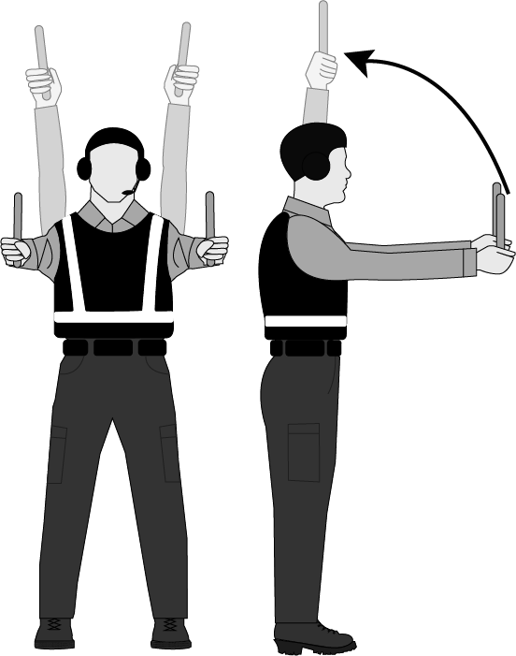
To move an aircraft forward in a straight line, the parking tender will utilize the Move Forward Hand Signal.
Stand facing the aircraft with arms extended from the shoulder to the sides. Both arms will bend at the elbow towards the head in unison and back down in a continuous motion while the parking tender wishes the aircraft to continue moving forward.
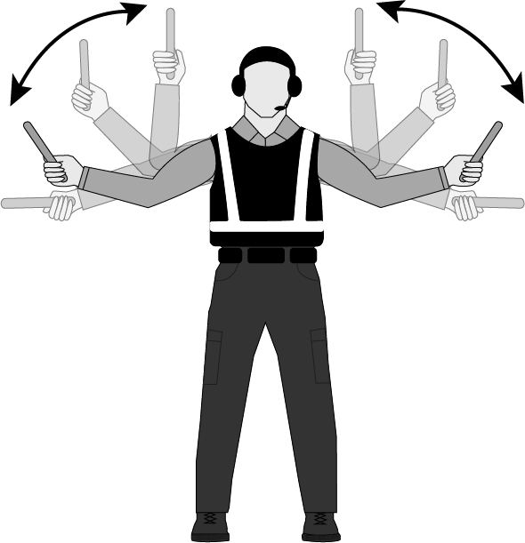
To turn an aircraft left, the parking tender will utilize the Left Turn Hand Signal.
Stand facing the aircraft with arms extended from the shoulder to the sides. The left arm will bend at the elbow towards the head and back down in a continuous motion while the parking tender wishes the aircraft to continue turning left.
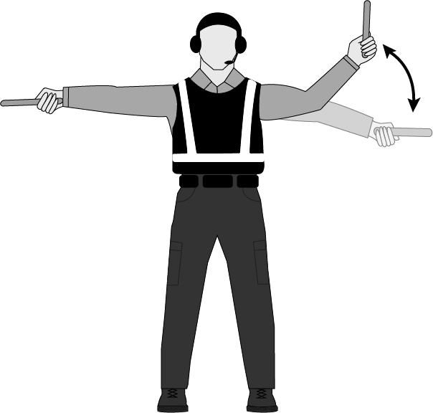

To turn an aircraft right, the parking tender will utilize the Right Turn Hand Signal.
Stand facing the aircraft with arms extended from the shoulder to the sides. The right arm will bend at the elbow towards the head and back down in a continuous motion while the parking tender wishes the aircraft to continue turning right.
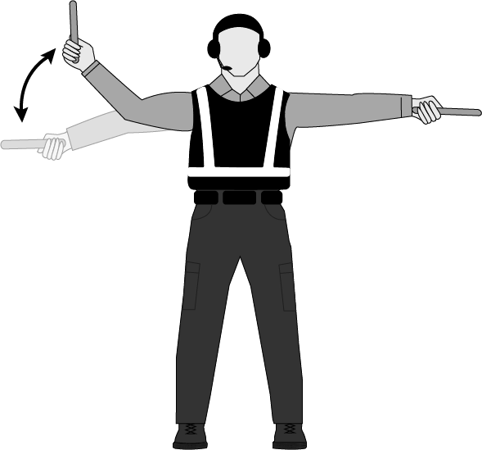
To stop an aircraft normally, the parking tender will utilize the Normal Stop Hand Signal.
With both arms straight at sides, raise both arms from shoulders in unison slowly and cross wands (or forearms) above head at the intended stopping point.
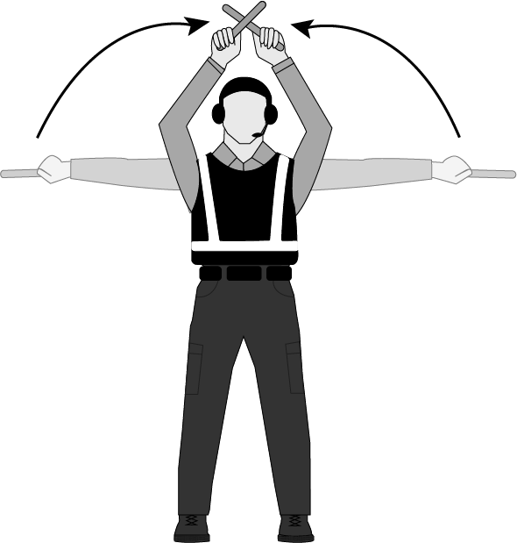
To stop an aircraft in the event of an emergency or possible collision, the parking tender, or wing walker will utilize the Emergency Stop Hand Signal.
With both arms extended from the shoulder and to the sides, quickly cross wands (or forearms) above the head in unison as many times as necessary for movement to stop.
*Parking tenders and wing walkers can also utilize radio communication while performing the Emergency Stop Signal.*
To pass control of marshalling off to another parking tender, the parking tender will utilize the Next Marshaller Hand Signal.
Extend one arm at the shoulder to the side and pointing at the next parking tender, move the other arm from the side up to meet the pointing arm. Repeat until aircraft turns to new parking tender.
*At this time, the parking tender may become a wing walker as needed.*
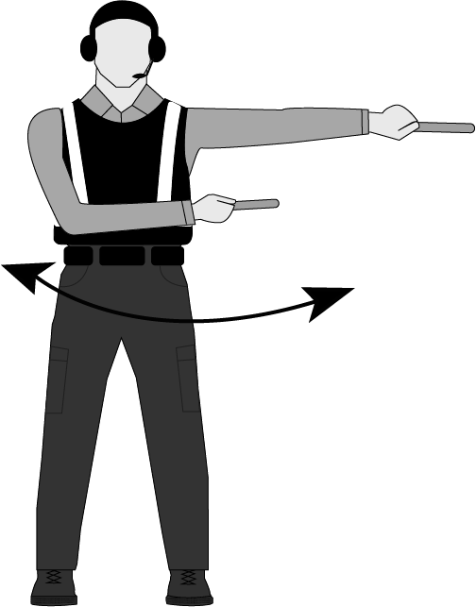
To request the flight crew, slow the taxi speed of the aircraft, the parking tender will utilize the Slow Down Hand Signal.
Raise both arms at the shoulder, begin waving both arms in unison from shoulder to waist until crew responds.
*If crew does not comply, stop the aircraft, and utilize the radio to relay instructions to flight crew.*
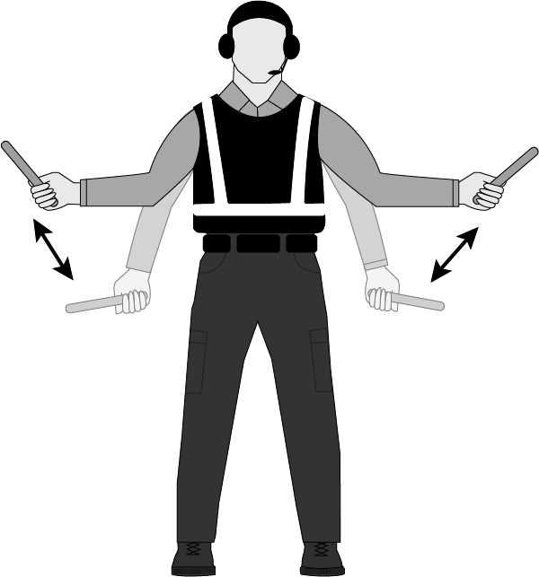
To request the flight crew to set the aircraft brakes, the parking tender will utilize the Apply Brakes Hand Signal.
With one (or both) hand(s) extended, palm(s) open above the head, close open hand(s) into a fist. The flight crew will respond with the same signal or Affirmative Signal.
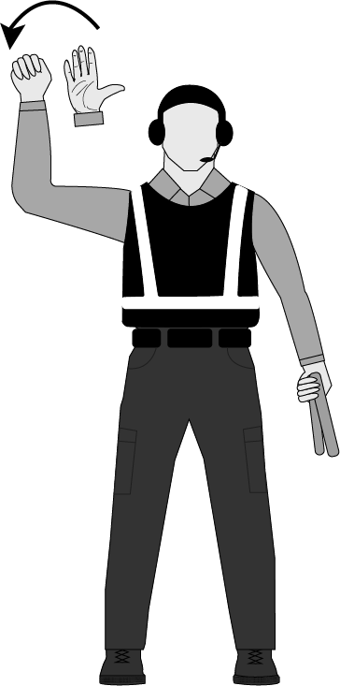

To request the flight crew to release the aircraft brakes, the parking tender will utilize the Release Brakes Hand Signal.
With one (or both) hand(s) extended in a fist above the head, open, and close hand(s) palm(s) out. The flight crew will respond with the same signal or Affirmative Signal.
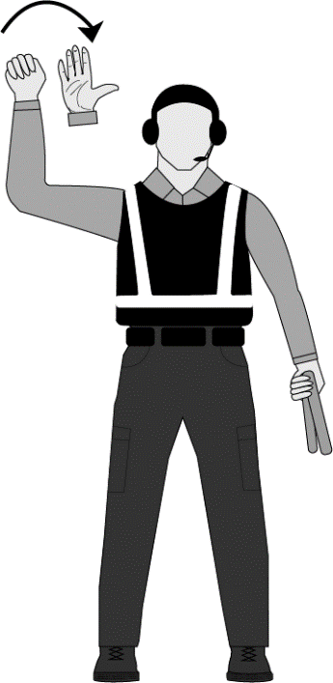
To inform flight crew of chocks inserted or flight crew requesting chocks, the parking tender will utilize the Chocks Inserted Hand Signal.
With wands (or hands) raised above the head at the shoulder, point wands (or thumbs) towards each other and move wands (or thumbs) together rapidly until flight crew acknowledges with the same signal or Affirmative Signal.
To inform flight crew of removing chocks or flight crew requesting chocks removal, the parking tender will utilize the Chocks Removed Hand Signal.
With wands (or hands) raised above the head at the shoulder, point wands (or thumbs) away from each other and move wands (or thumbs) away from each other rapidly until flight crew acknowledges with the same signal or Affirmative Signal.
When flight crews request the starting of engines, the parking tender will respond with the Start Engines Hand Signal. Point to the corresponding engine while rotating the other arm above the head in a 12-inch circle until the engine has started.
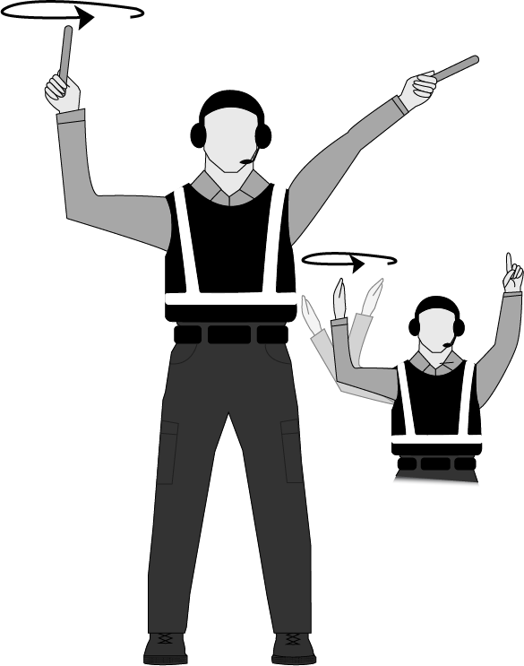
*Flight crews use numbers (number of fingers held up in the windscreen) to identify the engine to be started. Aircraft engines are numbered right to left from the parking tenders view (left to right from the crew’s point of view)—i.e., for an airplane that has two engines, the left engine from the parking tender’s point of view is #2 and the right engine is #1.
To acknowledge instructions or respond in the affirmative, the parking tender will use the Affirmative Hand Signal.
To respond to a request from the flight crew in the affirmative, extend the arm above the head at the shoulder with wand (or thumb) pointing up.
To refuse instructions or respond in the negative, the parking tender will use the Negative Hand Signal.
To respond to a request from the flight crew in the negative, extend the arm at the shoulder straight out to the side with wand (or thumb) pointing down.
When responding to the flight crew request to connect external power, the parking tender will utilize the Connect Power Hand Signal.
With arms above the head and palms open in a “T” formation, move lower hand towards upper hand.
*Contractors are responsible for connecting and energizing power carts to aircraft.*
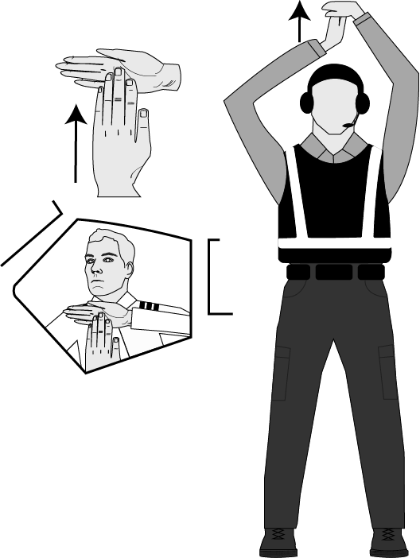
When responding to the flight crew request to disconnect external power, the parking tender will utilize the Disconnect Power Hand Signal.
With arms above the head and palms open in a “T” formation, move lower hand away upper hand.
*Contractors are responsible for disconnecting and removing power carts form aircraft.*
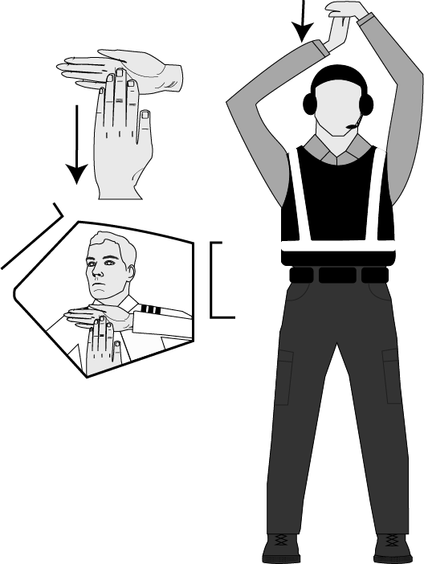
To inform the flight crew of the airstairs available for egress from the aircraft, the parking tender will utilize the Airstairs Available Hand Signal.
Raise one arm at shoulder to a 45-degree angle above the head. With the other arm, make a sweeping motion from side up to meet the raised arm.
*Contractors are responsible for moving airstairs to the aircraft.*
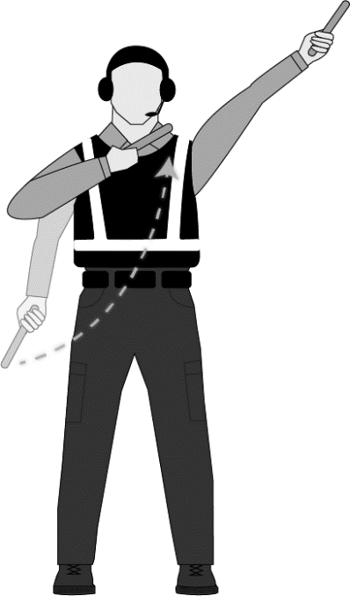
To inform the flight crew of the airstairs moving away from the aircraft, the parking tender will utilize the Airstairs Removed Hand Signal.
Raise both arms at shoulder to one side at a 45-degree angle above the head. Move the arm across the body down and to the side in a sweeping motion.
*Contractors are responsible for moving airstairs away from the aircraft.*
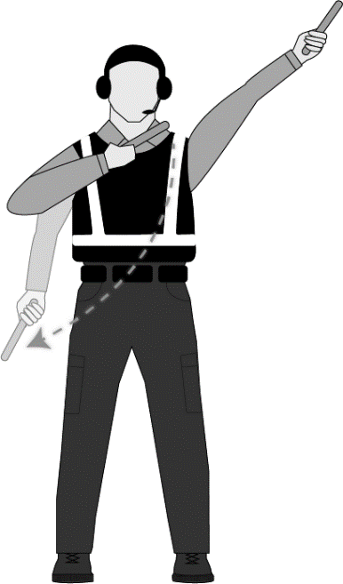

To inform the flight crew of end of marshalling, the parking tender will utilize the End of Marshalling Hand Signal.
In the style of military salute, raise hand to brow with fingers extended and move hand swiftly down and to the side.
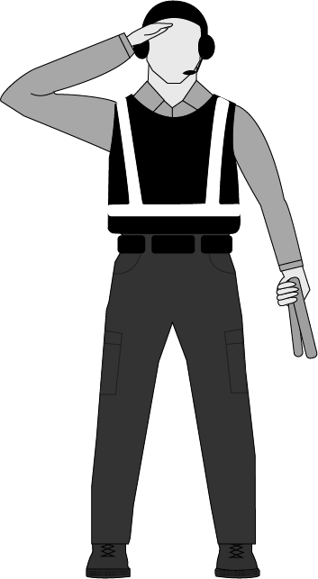
To inform the flight crew not to move flight controls (in the case of an obstruction), the parking tender will utilize the Do Not Move Controls Hand Signal.
With one arm extended to the side at the shoulder and arm bent at the elbow, hold wand at center point (or closed fist) until safe to move controls. If possible, parking tender should inform crew of obstruction over the radio.
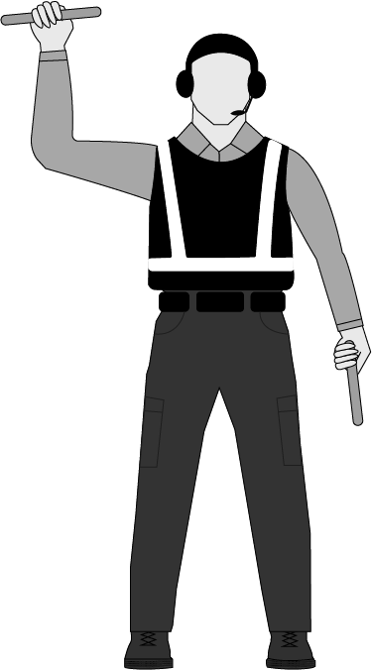

To inform crew of loss of radio communication, the parking tender will utilize the Loss of Communication Hand Signal.
Raise both hands and cover the ears. Repeat the motion until communication is re-established. The flight crew could utilize this signal to the parking tender to request radio communication.
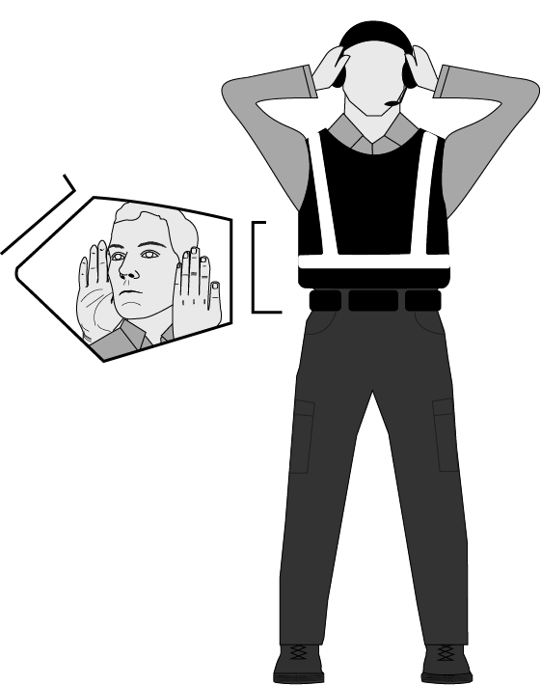
To inform the flight crew of an engine or brake fire, the parking tender will utilize the Fire Hand Signal. *This is an emergency signal and should be repeated over the radio.*
With one arm fully extended and pointing to the location of the fire (engine or brake), rapidly move opposite arm in a “figure 8” motion until crew is made aware of the emergency.
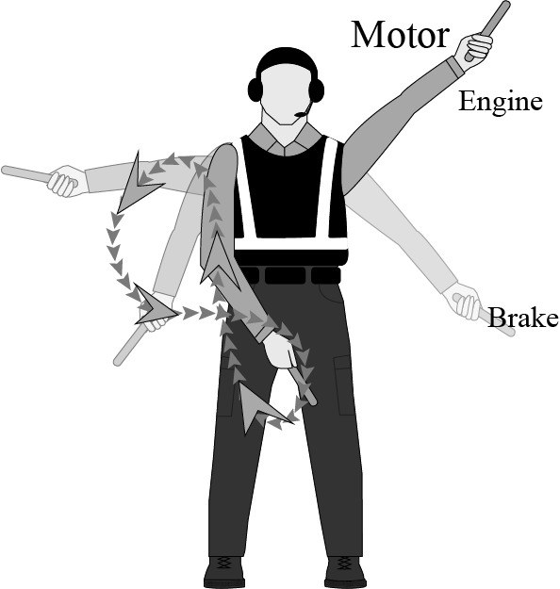
To inform the flight crew of the need to shut down an engine, the parking tender will utilize the Cut Engine Hand Signal. *This is an emergency signal and should be repeated over the radio.*
With arm extended pointing at the engine that needs to be shut down, the other arm will make a slashing motion with the wand (or thumb) across the throat rapidly until the crew is made aware of the emergency.
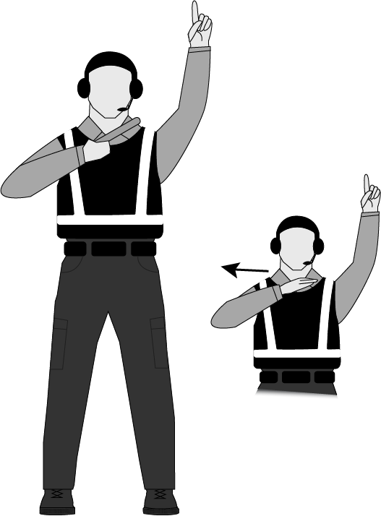
The proper signal for a stationary wing walker is wand (or hand with thumb up) extended above the head. If the aircraft comes within an unsafe distance of an object, the wing walker will utilize the Emergency Stop Signal and/or radio call until the operation stops.
The proper signal for a wing walker escorting an aircraft is wand (or had with thumb up) and opposite hand at side making a waving motion from shoulder.
If the aircraft comes within an unsafe distance of an object, the wing walker will utilize the Emergency Stop Signal and/or radio call until the operation stops.
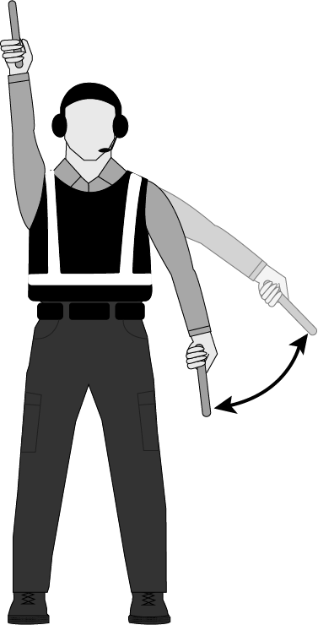

Appendix H: Additional Positions

Fixed Wing Base Manager (FWBM)

Introduction
The FWBM is a technical specialist and based upon need or local organization may be incorporated as part of an airtanker base operation. The FWBM reports to either the local Aviation Officer, incident Air Operations, Center Manager, or ATBM as appropriate.

Major Duties
Orders and secures all necessary ground facilities, supplies, and services required at the operating base. Requests communications and operations support through the air support group supervisor.
Ensures adequate staffing, supervises, and assigns specific duties to assigned base personnel including RAMP, FWPT, Drivers, and other base help.
Develops and implements accountability, safety and security measures for personnel and resources and is thoroughly familiar with and enforces all safety requirements for their work area.
- Is responsible for compliance with agency and state safety and health requirements for the work area.
- Serves as a liaison to airport management, federal, state, and local officials, and FBO.
- Conducts briefings with base personnel and contractors.
- Secures a priority list of air missions and schedule of flights.
- Obtains pertinent information on each aircraft assigned to the base.
- Coordinates all flights with the dispatch office.
- Maintains records on aircraft, equipment, and personnel assigned to the base.
- Receives overhead, crews, and supplies, and verifies arrangements for transportations to assigned destination.
- Regulates movement of assigned aircraft, motor vehicles, and personnel on the airfield.
- Supervises the demobilization of Unit personnel equipment and supplies.
- Ensure an accurate manifest (to include names, weight, maximum allowable takeoff weight) is completed for each load.

MAFFS Airtanker Base Manager (MABM)
This position reports to the MAFFS Liaison Officer (MAFF).
The MABM needs practical, in-depth knowledge of the full range of technical, managerial, and administrative methods, practices, and procedures relative to the MAFFS Coordinator/Manager function.

Major Duties
- Works with the MAFF and airport manager to decide on the locations at the airport to set up and operate a portable retardant base, if required.
- Coordinates with the MAFF and supplier of fire retardant on setting up the portable plant.
- Coordinates with the MAFF and initiates resupply orders and on orders of support equipment for the base. Inventories and replaces items as necessary from portable base kits.
- Works with the MAFF, AES/CC, and local fuel vendor on how and when the aircraft will be fueled.
- Serves as liaison with the local ATBM when operating from an established airtanker base.
- Coordinates with the MAFF to assess the size of the ground operation, and order personnel to staff it (e.g., retardant Mixmaster, compressor operators, forklift operators, etc.).
- Regulates all movement of aircraft, motor vehicles, and personnel being used around the retardant base operation.
- Attends daily briefings. Convenes daily meetings with all personnel (agency and military) assigned to work on the ramp. Makes assignments for the day and discusses any safety alerts.
- Maintains a daily unit log and provides copies to the MAFF.

MAFFS Airtanker Base Specialist (MABS)
This position is located at an airport at a MAFFS or Airtanker Base and is essential for safe operation on a MAFFS aircraft base of operations. This person is supervised by the MABM or the MAFF.

Major Duties
- Supervises FWPT and directs aircraft loaders, fuelers, forklift operators, and other personnel on the ramp area.
- Develops and provides briefings for pilots and fuelers on parking areas and ramp traffic patterns, communications on the ramp and emergency procedures.
- Coordinates all movement on the ramp for all aircraft, vehicles, and personnel. Maintains the overall readiness and safety of ramp facilities and operations. Orders supplies and services required at the base.
- Ensure that all personnel on the ramp have the applicable training for the missions they are assigned and documents any training provided for base personnel.
- Ensures the proper use of PPE by all personnel on the ramp. Establishes emergency ramp procedures and trains all personnel on these procedures. Ensures that all safety hazards and incidents are reported, and corrective actions are taken.
- Establishes fueling areas, loading pits, repair/maintenance areas, overnight parking areas, day-off parking areas, and general parking areas. Monitors and ensures the safety of all fueling operations.
- Help arrange transportation and lodging for transient aircrews and ensures meals and drinks are provided to pilots and contract personnel during periods of high fire activity to sustain operations. May work closely with retardant personnel, providing information on aircraft movements and retardant needs.

MAFFS Liaison Officer (MAFF)
This position is the liaison for the using agency and the military organization supplying retardant delivery service and is responsible to the National MAFFS Liaison Officer and the Regional or Geographical Area Coordinator (GACC) at the operation location.

Major Duties
- Makes initial contact and establishes communication channels with NICC, Regional/State Office, AES/CC, MABM, Unit Aviation Officer, Forest/District FMO, Airport Manager, FAA, IIO, and Military Base Commander.
- Coordinates with local dispatch to discuss ordering procedures and establish lines of communication, ensure that a MAFFS-qualified lead plane is available for each drop, identify local jettison area, obtain ETAs of aircraft, crews and equipment, arrange for flight following of aircraft inbound and outbound from incidents, obtain or develop flight hazard maps, arrange for fuel for military and lead planes, arrange for technical inspections of operation, aircraft and flight crews; arrange for maintenance inspections to get aircraft back in service; determine air availability.
- Orders support personnel consistent with MAFFS Operational Plan guidelines. Orders supplies and arranges for working space and other needs if the host unit cannot provide.
- Meets required daily reporting requirements to NICC and other interested parties as outlined in the MAFFS Operational Plan.
- Provides/arranges for logistical support within capabilities for personnel assigned to the MAFFS operation, including meals, housing, transportation, etc. Checks facilities and arrangements for the military crews with the AES/CC.
- Ensures radios are installed in MAFFS aircraft and that they are operational.
- Ensures that MAFFS maintenance personnel have been ordered.
- Obtains necessary information for daily briefings and briefs the MAFFS flight crews and incident Air Operations and ground support personnel on fire status and daily ATB operations. Facilitates debriefings/AARs, appraisal of capabilities, lessons learned and formal report, and final cost.
- Maintains daily unit log and provides copies to the MAFF file.

Field SEAT Coordinator (SECO)
The SECO position was developed to be mobilized at a state or regional level to help coordinate SEAT operations within a geographical area. The intent for the SECO is to work with all interagency partners within the defined area. Efforts for mobilizing a SECO for a specified area should involve coordinating with all agencies utilizing SEATs within that area. While deployed, the SECO will be under the day-to-day direction of the local State Aviation Manager (SAM) or Regional Aviation Officer (RAO).
The SECO must be a currently qualified SEMG with a minimum of five years of experience as a SEMG.

Delegation of Authority
The SECO will receive written delegation of authority identifying the participating agencies, points of contact, and assignment objectives.

Duties and Responsibilities
- Perform as a liaison between the agency and each SEAT base of operations.
- Perform base inspections in the field using the standard SEAT base inspection form developed for pre-season or readiness reviews. Assist in rectifying any discrepancies.
- Offer recommendations to improve safety and operational efficiency.
- Report all concerns/issues to the SAM/RAO as they are discovered or occur.
- Perform area inventory for possible temporary SEAT bases. Compile a list of each prospective base of operations, listing the location, local contacts, and phone numbers, latitude and longitude, and length, width, and composition of the landing surface. Provide a list of all the facilities and identify those that would be available for use by the agency for SEAT operations. Identify any restrictions or possible limitations of each site.
- Assist the agency personnel with developing agreements or Memorandums of Understanding (MOU) for the use of airports or airstrips. Provide procurement officer with general information to help them establish agreements with local contractors for water, equipment, and supplies that may be needed for SEAT operations. (Note: The SECO does not have the authority to procure any contractors or make any agreement for rental or lease.)
- Assist agency unit aviation managers with deployment and movement of SEAT resources. Identify the capabilities and limitations of the resources that are available for deployment. Coordinate with state/regional level aviation managers and Multiagency Coordination (MAC) groups.
- Assist the using agency with finding available SEMGs and temporarily fill in for SEMGs on their days off when necessary.
- Perform an evaluation of the SEMG and base operations. Offer assistance and recommendations to the SEMG to provide a more efficient and effective base of operations.
- Provide assistance to SEMG for completing a contractor performance evaluation of the SEAT pilot and support personnel.
- Has the authority to sign off specific tasks within the guidelines of the SEMG Position Task Book.
- At the conclusion of the assignment, complete a written report to present to the local SAM or RAO as well as conduct a closeout briefing. Compile a comprehensive report on all SEAT operations that were reviewed within the assigned geographical area, containing evaluations of contractor performance, SEAT base operations, SEMG evaluations, and the agency’s utilization of the SEAT in their fire program.

Appendix I: Staffing Matrix
Each agency and unit is required to provide a professional air base workforce. The base organization must be commensurate to the needs and use of the base. NWCG recognized air base positions support the various functions of an air base (ATBM, SEMG, FWBM, RAMP, FWPT, ATIM, MXMS, RTCM). All are critical positions and must be reflected within daily air base staffing as appropriate for the base operation. It is incumbent upon the administering unit to ensure the airtanker base is adequately staffed with qualified personnel to meet the operational capabilities of the base.
Base managers have the day-to-day responsibility to identify the number and positions needed daily to staff the airtanker base, given the current, and expected fire activity, complexity, potential for additional aircraft, and operational tempo. Qualified individuals may assume more than one role, but no more than two positions concurrently. Complexity and span of control issues can restrict the ability to perform dual roles safely and effectively.
Mobile Retardant Bases (MRB) shall be staffed to the bulk base staffing level (agency and/or contract personnel). See MRB contract for the vendor provided staff.
The below Staffing Matrix is representative of base staffing configurations to support airtanker loading operations.

Minimum Staffing Levels Required for Operations
Staffing Configurations
Agency/Vendor Personnel
# Of Airtankers | Full-Service | Bulk Service | Total ATB Personnel
Up to 4 @ LAT Base | ATBM + ATIM + RAMP + FWPT (1 per Pit) | ATBM + ATIM + RAMP + FWPT (1 per Pit) + MXMS + RTCMs (2 per Meter) | Full-Service – 4  Bulk Service – 7
5 and Greater @ LAT Base | ATBM + ATIM + RAMP + 3 FWPTs | ATBM + ATIM + RAMP + 3 FWPTs + 3 RTCMs + MXMS | Full-Service – 6  Bulk Service – 10
Up to 4 @ SEAT Base | SEMG or ATBM + 1*  *(Additional personnel can be ATBM, SEMG, RAMP, ATIM, FWPT) | SEMG or ATBM + 1* + RTCM + MXMS *(Additional personnel can be ATBM, SEMG, RAMP, ATIM, FWPT) | Full-Service – 2  Bulk Service – 4
5 and greater @ SEAT Base | SEMG or ATBM + 2*  *(Additional personnel can be ATBM, SEMG, RAMP, ATIM, FWPT per pit in use) | SEMG or ATBM + 2* + RTCM + MXMS  *(Additional personnel can be ATBM, SEMG, RAMP, ATIM, FWPT per pit in use) | Full-Service – 3  Bulk Service – 5
Are wing walkers needed? Increase the number of FWPTs as needed for safety.
Full-service tanker bases meet staffing requirements through the retardant vendor.
The staffing listed above is a MINIMUM. In this matrix, a “Pit” is referenced for when it is in use.
This Staffing Matrix DOES NOT account for days off OR 7-day coverage of the Airtanker Base.
This table does not cover additional complexities, multiple pits in use, simultaneous loading, or non-airtanker aircraft also located at the base.

- A qualified base manager (ATBM/SEMG) is required to be assigned any time a full-service base is within its Mandatory Availability Period (MAP), even if no airtankers are currently on-site.
- A qualified ATBM/SEMG may be tasked to perform any of the duties of ATIM/RAMP/FWPT/MXMS/ RTCM if qualified. Similarly, other positions may situationally perform other duties as qualified. The level of activity and span of control will dictate the need to assume these collateral duties. As activity or complexity increases, dual-function roles should be avoided.
- Each base is unique and may present complexities and operational challenges to personnel staffing configurations that are not representative of the above matrices. Bases that cannot provide staffing for current and expected activity must restrict the number of aircraft to a level that is safely manageable for the base.
- The above number of airtankers and corresponding staffing configurations are assuming the operation of a single loading pit.
- The vendor at full-service retardant bases provides their staffing configurations, therefore, it is not accounted for in the above matrices.
- Two separate airtanker loading operations (e.g., addition of a mobile retardant base) on the same airport should be managed and staffed as separate base operations.
- The ramp must be managed at all times. It is the responsibility of the ATBM/SEMG to maintain a safe and efficient operation. Contractor/Vendor personnel are not to marshal aircraft while on the airtanker base ramp.
- Each loading operation must have a FWPT assigned. Other operational areas may necessitate the use of additional FWPT(s).
- Experience and competence levels will differ among personnel. It is the ATBM/SEMG and/or RAMP responsibility to assess skills and abilities and oversee trainees. It may be necessary to provide supplemental personnel to support trainees, etc.
- Airtanker turn-around times may dictate the need for additional or fewer personnel.
- All positions will meet training and qualifications as outlined in the PMS 310-1 and the standards identified in the SABO.
- At a LAT base that is operating multiple LATs and SEATs, consider ordering a SEMG.
- A qualified ATBM/SEMG may administratively manage up to four SEATs but may operationally manage more as necessary. (e.g., multiple SEATs operating out of a base during the day while being administered by their assigned manager).
- Contractor/vendor personnel are responsible for training their own RTCM/MXMS when operating agency or contractor provided equipment. An operational briefing must occur before operation.
Note: Agency Mixmasters (MXMS) may not use SEAT vendor equipment to mix retardant. Agency RTCMs may utilize vendor loading hoses to load the aircraft. Refer to the Agency Retardant Contract for equipment specifics for each base.

Appendix J: Suggested Minimum Equipment at an Airtanker Base
Fire extinguisher per loading pit and fuel servicing areas
Outside audio system (public address)
Telephone or cell phone communication capability
Handheld radios with headsets for ramp personnel
Dispatch radio system – VHF-AM and VHF-FM
Gasoline powered back-up retardant pump
Chock blocks for each aircraft
First Aid Kit – 10-person minimum
Body fluids barrier kit
High visibility vest for each RAMP (Green) and FWPT (Orange) and RTCM (Blue)
Smart TV for briefings
Organizational chart board
Wi-Fi capability
Computer and printer with internet access to obtain critical safety information, agency/incident mail, and SAFECOMs
Safety signs as required to meet OSHA/State regulations
OSHA and NFPA 30 certified flammable liquids storage cabinet
Labor/Civil Rights/OSHA poster to meet federal/state regulations
Safety Data Sheets and binder to meet OSHA/state regulations
Wash down water/retardant collection containment or collection system
Spill containment kit for fuel and other chemical spills
Current Aerial Hazard map
Refractometer, labels, and packaging to meet LA/QA for fire retardant
Eye/shower wash stations
Copy machine
Microwave oven
Air compressor
Pressure washer
Forklift and/or hand truck
Vehicle for obtaining supplies and transporting personnel
Refrigerator
Vacuum cleaner
Commercial Ice maker / bagged ice freezer
Large capacity coffee maker
Battery charger
Ladder (6-foot minimum)
Washer and dryer
Erasable briefing board
Electrical outlet (for each loading pit). Class A installation or as required by local code
Tool kit
Lock out, tag out kit
Mass flow meter
Pipe wrench (36-inch aluminum)
Appropriate hose, appliances, and accessories for operations
Spare refractometer
Banding tool kit

Appendix K: Daily Operational Briefing Materials
• FAA TFR http://tfr.faa.gov/tfr2/list.jsp
• National Situation Report https://www.nifc.gov/nicc/sitreprt.pdf
• NOAA Fire Weather https://www.weather.gov/fire/
• Local GACC Morning Report
• 6 Minutes for Safety https://www.nwcg.gov/committee/6-minutes-for-safety
• Local airspace deconfliction/aerial hazards
• Aircraft availability
• AAR for airtanker base operations from previous day
• Round Robin for today’s activity (retardant contractor, federal, state, aircrews)
• Bulletins
• Risk Assessment/General Assessment of Risk (GAR)
• Wildfire Lessons Learned https://lessons.wildfire.gov/
• NOTAMs https://notams.aim.faa.gov/notamSearch/nsapp.html#/
• Relevant SAFECOMs https://www.safecom.gov/
• Staffing and assignments

Appendix L: Daily Risk Assessment

General
Personnel who are informed on tactics and strategies and supported by sound risk management decisions as well as having received timely safety reminders will add to the overall safety and effectiveness of an operation. Positive leadership ensures risk assessments are accomplished in a professional, effective manner.
Completed by ATBM/SEMG in conjunction with aircrews
Points (Risk Level)
Risk | 1 (Low) | 2 (Medium) | 3 (High)
Fire Weather | No adverse forecast, Haines Index 4, or below | Forecast T-Storms or Red Flag conditions, Haines Index 4-5 | Active T-Storms in area, Haines Index 6, Red Flag in effect
Winds @ Base | <15 Knots | 15-25 Knots | >25 Knots
Winds@Fire¹ | <15 Knots | 15-25 Knots | >25 Knots
Gust Spread | 0-5 Knots | 5-10 Knots | 10-15 Knots
Crosswinds | <10 Knots | 10-15 Knots | >15 Knots
Visibility | >3 Miles | 2-3 Miles | <2 Miles
Temperature (F) | <90º | 90º–100º | >100º
Density Altitude | <5,000' | 5,000'-8,000' | >8,000'
T/O Distance² | <50% | 50%–80% | >80% 3
Fatigue⁴ | <15 Hours | 15-25 Hours | >25 Hours
1–If fire winds not available, use nearest airport/reporting station/launch base information.
2–T/O distance measured as a percentage of available runways.
3–Consider Aircraft Download.
4–Measured in hours of flight time over the previous 5 days.
Total Points Risk Level Action
10-16 (Low) Pilot review of areas > 1 before flight.
16-23 (Medium) Review conditions with a/c or airbase manager before dispatch.
>23 (High) Notify local aviation manager or duty officer of conditions and potential delayed response until aerial supervision or on-scene resources report on conditions or conditions improve.
Conditions must be monitored throughout the day and re-evaluated, as necessary.
Wind limits:
- SEAT 30 knots 15 knot gust spread.
- Heavy Tanker generally ineffective in winds over 20-25 knots.
- Type 3 helicopters 30 knots 15 knot gust spread.
- Type 2 and 1 helicopters 40 knots 15 knot gust spread.
Daily General Assessment of Risk (GAR) for ____________ Airtanker Base
Date: ____________ Name: ___________________ (person filling out form)
Risk | 1 (low) |  | 2 (Medium) | 3 (High) |  | TOTAL
Airtanker Base Manager | Qualified and knowledgeable in base policy, personnel, capabilities, and limitations. Works at the base or has been to the base on multiple assignments in a supervisory position. Is familiar with local unit organization and policies. |  | Working knowledge of the base’s capabilities and limitations or a trainee in the position. May have some local knowledge or filled in at the base within the past few years. | Qualified or trained but has limited knowledge about the base capabilities and limitations. Is unfamiliar with the appropriate controls to minimize risk. Has not been to the tanker base before and is building local knowledge.
Airtanker Base Personnel  (RAMP, ATIM, MXMS, FWPT, RTCM) | All positions are qualified, briefed, healthy, and rested prior to starting operations. Tanker base positions are assigned, and responsibilities are understood. Operations are performed with limited supervision. Personnel issues are addressed, and little external stress is being exerted. Have been to the base on multiple 2-week details in their current position. |  | Are mixed with qualified and trainees (1:1). SABO and local base knowledge are in practice and being learned. Local base standards are being learned. Ramp positions and responsibilities are being developed. Transitioning personnel. | Limited qualified personnel available leading to juggling of responsibilities to achieve mission success. Trained personnel are lacking local base knowledge, setup, and practices. Proficient communication practices are lacking or being built. RAMP positions and responsibilities are unclear.
Base Environment | Is conducive to the best possible chance of success for daily operating. Airtanker base, ramp, and retardant plant are well maintained with daily maintenance completed. No airport construction or known interruptions to base operations. |  | Weather is transitioning, potentially leading to drastic changing conditions later in the day. Ramp parking space is at half or more capacity. Airport construction is underway, and mitigations have been communicated and are in place. Repairs to base, ramp, or retardant plant ongoing. | Winds are unpredictable. Base and/or ramp in need of immediate repairs. Airport or non-tanker base operations create interruptions or shut down of base operations. Operational tempo is too low or too high. Ramp parking is FULL.
Operational Complexity | Single agency aircraft and personnel from the same unit or who work together regularly. Operations are straightforward and covered by the SABO and local base plans. Fire support is at a minimum. |  | Operational tempo is changing. Initial Attack activity is high with Extended Attack activity building. Multiple days (2+) being flown on the same fires. Supporting multiple agencies’ needs. | Multiple agencies are involved in missions. Personnel are new to each other and come from different cultures. Many leaders are emerging and working toward different objectives. Fire activity is numerous with support being flown to different incidents.
Fueling Operations | Are timely and proficient. No issues to operations. |  | Are causing longer than usual delays in airtanker operations. Other airport operations outside of airtanker base’s control are taking precedence. | Are impeding effective operations at the base. Fuel is limited or not available from vendor. Operations have the potential to be halted.
Additional airtankers  the base could be supporting in the area | 0 to 4 |  | 5 to 8 | 9+
Fire Weather | No adverse forecast. Haines Index below 4. |  | Forecast T-storms or Red Flag conditions, Haines Index 4, or 5. | Active T-storms in area, Haines Index 6. Red Flag in effect.
Temperature | <90° |  | 90° - 100° | <32° or >100°
Fatigue | 9 hours daily |  | 10-13 hours daily | 14+ hours daily
*Completed by Base Management in conjunction with key base personnel. |  |  |  |  | Total Points
Risk Level / Action:  (Circle level that corresponds to daily total) |  | Low (9 to 16) – Consider: base personnel complete their daily review of the base and ramp prior to operations.  Medium (17 to 22) – Consider: base manager reviews conditions with airtanker base personnel prior to operations.  High (23 to 27) – Consider: base manager will notify the local FAO/UAM or Duty Officer of conditions and potential delayed response until conditions improve.

Appendix M: Airtanker Base Readiness Review

Introduction
An evaluation of airtanker base personnel and designated airtanker bases should be conducted as part of pre-season preparation. The local unit should have adequate time, as identified by the evaluators, to respond to the evaluation and to identify corrective action planned or already taken.

Purpose
The purpose of the Readiness Review is to evaluate the general readiness of the airtanker base, and identify, and correct any safety or operational deficiencies related to the airtanker base or personnel. It should be stressed that the evaluation process is meant to be a constructive process.

Applicability
The format as contained in the Readiness Review is optional, and agencies/regions may have specific checklists. However, individual agency manual or handbook direction may require completion through reference to the SABO.

Responsibility
Evaluations should be conducted annually or otherwise at management discretion. Aviation management at the regional, state, or local level is responsible for facilitating the evaluation.
Team conducting this review:
Name | Agency | Phone/Email

Sections
Section A – General
Section B – Base Facilities and Communications
Section C – Planning and Administration
Section D – Ramp Operations
Section E – Retardant Operations
Section F – Personnel
Section G – Safety and Security
Section H – Summary
Section I – Evaluators Signatures

Section A: General
Base Name:
Managing Agency:
Types of Operations Conducted:
Large Airtanker ☐
SEAT ☐
VLAT ☐
Helitanker ☐
Rotor Wing ☐
Air Tactical ☐
Smokejumper ☐
Other ☐
Hosted aircraft at Base (list):
Has the information for this base been updated in the NWCG Airtanker Base Directory for this year? ☐ Yes ☐ No

Position | Filled, Vacant or n/a | Remarks
Airtanker Base Manager
Asst. Airtanker Base Manager
Airtanker Base Technician
Airtanker Base Technician
SEAT Manager
Mixmaster
Retardant Crew Member(s)
Ramp Manager
Fixed-Wing Parking Tender(s)
Aircraft Timekeeper
Other Position(s)
See Base org chart/staffing matrix for more information.

Section A: General (continued)

Retardant Vendor | Filled, Vacant, or n/a | Remarks
Base Manager/Mixmaster
Asst. Manager
Retardant Crewmembers
Notes:

Section A: General (continued)
Key Code: E = Exceeds M = Meets Standard NI = Needs Improvement NR = Not Reviewed
Item  # | Evaluation Criteria | Code | Remarks
A1 | Base has on-site staffing 7 days a week during fire season. (Note how many in Remarks.) | Choose an item.
A2 | Additional staffing is available and a plan is in place to maintain staffing when activity increases. | Choose an item.
A3 | ATBM does not have collateral duties during fire season. | Choose an item.
A4 | Base has qualified ATBM coverage during operations. | Choose an item.
A5 | Qualified MXMS and RTCM positions are filled. (note in Remarks if Vendor or Agency) | Choose an item.
A6 | Qualified RAMP and ATIM positions are filled. | Choose an item.
Notes:

Section B: Base Facilities and Communications
Item # | Evaluation Item/Criteria | Code | Remarks
B1 | Base has adequate space for the number of personnel assigned and for intended operations. | Choose an item.
B2 | Operations area provides adequate visibility of arriving and departing aircraft. | Choose an item.
B3 | Operations area is well organized (materials and references accessible and labeled, maps on wall, etc.) | Choose an item.
B4a | Back-up power system is available at the base for the operations area. | Choose an item.
B4b | Back-up power system is available for the retardant plant. | Choose an item.
B5 | Communications Plan is available , and frequencies (Initial Call-in, AirNet, Forest/Field office Net, Ramp) are included in this plan. | Choose an item.
B6 | Base has VHF-AM equipment. | Choose an item.
B7 | AFF and viewing monitor is available. | Choose an item.
B8 | ATIM knows proper radio use procedures. | Choose an item.
B9 | Telephone system is adequate for intended activity. (numbers of lines and phones). | Choose an item.
B10 | Appropriate phone numbers are clearly posted. (local dispatch, crash-rescue, FBO, etc.) | Choose an item.
B11 | A public address system is available at the base. | Choose an item.
B12 | Pilot Ready-Room/Standby Area is adequate. | Choose an item.
 | Air conditioning / Heating | Choose an item.
 | Hot and cold potable water | Choose an item.
 | Shower | Choose an item.
 | Restroom facilities | Choose an item.
 | Lounge area | Choose an item.
B12 (cont.) | Adequate lighting | Choose an item.
 | Lockers | Choose an item.
 | Desks | Choose an item.
 | Wi-Fi/internet access | Choose an item.
 | Flight planning area | Choose an item.
 | Eating facilities | Choose an item.
 | Sleeping and resting facilities | Choose an item.
 | Refrigerator | Choose an item.
 | Washer/Dryer | Choose an item.
Notes:

Section C: Planning and Administration
Item  # | Evaluation Item/Criteria | Code | Remarks
C1 | The following references are available at the base and easily accessible (electronic or hard copy): | Choose an item.
 | Aviation Management Manuals and Handbooks (all cooperators) | Choose an item.
 | Health and Safety Codes for the appropriate agency | Choose an item.
 | NWCG Standards for Airtanker Base Operations, PMS 508  Current airtanker contracts | Choose an item.
 |  | Choose an item.
 | Communications Plan | Choose an item.
 | NFPA 407 Standards for Aircraft Fuel Servicing | Choose an item.
 | Geographic Area Mobilization Guide and Local Plans from appropriate agencies | Choose an item.
 | NWCG Standards for Airspace Coordination | Choose an item.
 | Emergency Response Plan | Choose an item.
 | Interagency Standards for Fire and Fire Aviation Operations (Red Book) | Choose an item.
 | NWCG Standards for Helicopter Operations | Choose an item.
 | NWCG Standards for Aerial Supervision | Choose an item.
C2 | Aerial supervision procedures are understood where applicable to airtanker operations. | Choose an item.
C3a | Base personnel are aware of the national policy concerning airtanker rotation. | Choose an item.
C3b | Base personnel are aware of dispatch requirements. | Choose an item.
C3c | Base personnel are aware of the exceptions to the 15-minute dispatch/reaction time clause. | Choose an item.
C3d | Base personnel are aware of the policies concerning startup/cutoff times and requirements. | Choose an item.
C4 | Sunrise/sunset chart is posted. | Choose an item.
C5 | Adequate forms of transportation for base personnel are available. | Choose an item.
C6 | Aircraft timekeeping procedures have been established. | Choose an item.
C7 | Base has established procedures for flight following (AFF). | Choose an item.
C8 | Map of known local aerial hazards is posted and updated annually. Incoming aircrews are provided a briefing on local known hazards. | Choose an item.
C9 | The Local ABOP is updated, approved, and available for all personnel | Choose an item.
C10 | The Local ABOP discusses the following: | Choose an item.
 | A current organization chart for the airtanker base | Choose an item.
 | A current organization chart for the local air attack organization | Choose an item.
 | A map of the local area with prominent landmarks | Choose an item.
 | A map with zones of influence /initial attack areas | Choose an item.
 | A map with local airfield hazards/jettison areas | Choose an item.
 | A list of equipment and parts at the base | Choose an item.
 | Description of fuels and fire behavior common to the area | Choose an item.
 | Agency responsibilities (especially at interagency bases) | Choose an item.
 | Duties and responsibilities of airtanker base personnel (as they differ from those in the SABO) | Choose an item.
 | Local aircraft contract administration procedures | Choose an item.

Item  # | Evaluation Item/Criteria | Code | Remarks
C10  (cont.) | FWPT roles and responsibilities during fueling operations | Choose an item.
 | Use of forms and reports (aside from those outlined in the SABO) | Choose an item.
 | Local procedures for payment of landing fees and airport use costs | Choose an item.
 | Procedures for submission of payment documents | Choose an item.
 | Retardant contract administration procedures | Choose an item.
 | Retardant billing procedures | Choose an item.
 | Local airfield management (procedures/regulations) | Choose an item.
 | Use of night lighting equipment | Choose an item.
 | Base electrical system (normal and emergency) | Choose an item.
 | Base security plan | Choose an item.
 | Aircraft Operating Plans that base is approved for | Choose an item.
 | Use of mass flow metering system for safety and or payment | Choose an item.
 | Wash down / spill recovery and waste disposal procedures | Choose an item.
C11 | The Base Hot Loading Plan is updated, approved, and available for all personnel. | Choose an item.
C12 | The Base Simultaneous Fueling and Loading Plan is updated, approved, and available for all personnel. | Choose an item.
Notes:

Section D: Ramp Operations
Item  # | Evaluation Item/Criteria | Code | Remarks
D1 | Ramp is capable of accommodating how many airtankers? (VLATs, large airtankers, and SEATs)
 | In the loading pits
 | Loading simultaneously
 | Parking
 | Space for unavailable aircraft
D2 | Ramp surface is in good condition. | Choose an item.
D3 | Taxi lines and ramp are adequately marked and visible. | Choose an item.
D4 | Wind indicator(s) are properly placed. | Choose an item.
D5 | Foreign object debris (FOD) measures are in place. | Choose an item.
D6 | The following warning signs are posted as appropriate: | Choose an item.
 | No smoking
 | Hazardous Areas
 | Authorized parking signs
 | Signing and marking for Ramp Security
 | Vehicle control signs designated to restricted areas
D7 | Ramp area is fenced and can be secured. | Choose an item.
D8 | Aircraft type fire extinguishers are available. | Choose an item.
D9 | Fire extinguishers are the proper type and have been inspected. | Choose an item.
 | Number
 | Type
D9 (cont.) | Capacity
 | Condition
 | Dates of last inspection
D10 | Airtanker base personnel have received annual training in crash-rescue procedures and use of fire extinguishers. | Choose an item.
D11 | A sufficient/serviceable number of chock blocks for aircraft are available and personnel are aware of their proper use. | Choose an item.
D12 | Standard hand signals and color-designated vests are being used. | Choose an item.
D13 | Night and day wands are available and being used. | Choose an item.
D14 | Sufficient tie downs for light aircraft and SEATs, etc. are available. | Choose an item.
D15 | A night lighting kit is available for night maintenance, etc. | Choose an item.
D16 | A first aid kit is maintained and readily available at the ramp. | Choose an item.
D17 | Catwalks and ladders are adequate to meet OSHA standards | Choose an item.
D18 | Walkways on tanks are painted with non-skid type paint. | Choose an item.
D19 | Pump shafts have guards. | Choose an item.
D20 | Eyewash and emergency shower facilities are provided. | Choose an item.
D21 | Adequate PPE is provided and used appropriately. | Choose an item.
D22 | The base has adequate noise-cancelling headsets with push-to-talk capabilities. | Choose an item.

Notes:

Section E: Retardant Operations
Item  # |  | Evaluation Item/Criteria |  | Code | Remarks
E1 |  | The retardant plant at the base is operated by vendor or agency personnel? |  | Choose an item.
E2 |  | The retardant mixing and storage equipment is owned by vendor or agency? |  | Choose an item.
E3 |  | Retardant mixing and storage equipment matches Section J. |  | Choose an item.
E4 |  | Type of retardant and storage capacity at base.
 |  | Wet
 |  | Dry
E5 |  | Adequate storage area is available for retardant. |  | Choose an item.
E6 |  | Adequate supply of retardant is available, and personnel are aware of procedures for re-order. |  | Choose an item.
E7 |  | Retardant testing equipment and charts available and personnel are knowledgeable in their use. |  | Choose an item.
E8 |  | Mass flow meter is in use and being used properly. |  | Choose an item.
 |  | Last calibration date?
E9 |  | Base has an adequate water supply. |  | Choose an item.
 |  | Gallons available for immediate use?
E10 |  | Base has offloading capability. |  | Choose an item.
E11 |  | Base has adequate washdown capability and facilities. |  | Choose an item.
E12 |  | Retardant spills and washdown areas are drained properly. |  | Choose an item.
E13 |  | How many aircraft can be loaded simultaneously?
 |  | Loading capability is adequate for the level of activity for the base’s zone of influence. |  | Choose an item.
E14 |  | Pumping system (hoses, caps, lines, pumps) is in working order. |  | Choose an item.
 | E15a |  | Does the base hot load airtankers? | Choose an item.
 | E15b |  | Does the base fuel and load simultaneously? | Choose an item.
 | E15c |  | If yes, have all personnel received the required training for that operation and is there supporting documentation? | Choose an item.
 | E16 |  | Retardant samples are being sent to WFCS as required. | Choose an item.
 | E17 |  | Feedback on samples is being received from WFCS and corrective actions are being taken in a timely manner. | Choose an item.

Notes:

Section F: Personnel
Item  # | Evaluation Item/Criteria | Code | Remarks
F1 | All base personnel meet training requirements for position(s) filled. | Choose an item.
Notes:

Section G: Safety and Security
Item # | Evaluation Item/Criteria | Code | Remarks
G1 | Local, Regional, and National Security Plans are on file and current (as applicable). | Choose an item.
G2 | Regular safety/security briefings are being conducted and documented . | Choose an item.
G3 | Facility safety inspections are being conducted and documented. | Choose an item.
G4 | Are background security checks required? | Choose an item.
G5 | An adequate Security Operations Plan is in place. | Choose an item.
G6 | Facilities security/surveillance systems are in place. | Choose an item.
G7 | The local airport authority is included in the base security plan. (Note any security deficiencies in remarks) | Choose an item.
G8 | Required OSHA plans are in place (Lock Out Tag Out, Hazardous Energy, Right to Know, Injury Illness Prevention Plan, SDS Station, Materials Identification, Confined Space, etc.) | Choose an item.
G9 | JHAs/or equivalent are up to date and on file. | Choose an item.
G10 | Training documentation is up to date (First Aid, Fire Extinguisher, Forklift, Crash-Rescue, etc.) | Choose an item.
G11 | Flammable Materials Storage Lockers are in place and in use. | Choose an item.

Notes:

Section H: Summary
- Identify any major deficiencies and corrective actions to be taken below.
General Readiness of the Airtanker Base Facility
Recommendations and Follow Up:
Due Date | Reference Evaluation Section | Recommendations | Completion Date

- Identify any major deficiencies and corrective actions to be taken below.
General readiness of the airtanker base personnel
Recommendations and Follow Up:
Due Date | Reference Evaluation Section | Recommendations | Completion Date

Section I: Evaluators’ Signatures
Evaluator Name: Signature
Evaluator Agency Date:
Evaluator Name: Signature
Evaluator Agency Date:
Evaluator Name: Signature
Evaluator Agency Date:
Evaluator Name: Signature
Evaluator Agency Date:
Review by Local Management
Line Officer Name: Signature
Line Officer Agency Date:

Appendix N: Recommended Reference Library
In addition to the latest version of the SABO, each airtanker base should have a library that includes the references below. Base managers are responsible for maintaining the most current versions of the recommended references listed.
The most current manuals and handbooks are the electronic versions maintained by the respective agency. They can be accessed through internal mail systems or the internet.
Many of these publications may be accessed on the internet. If they are maintained in hardcopy at the base, they must be the most current version.
- National/Regional/State/Unit Aviation Plans
- Local ABOP
- Airtanker Base-Specific Simultaneous Fueling and Loading Plan
- Airtanker Base-Specific Hot Loading Plan
- Airtanker Base Security Plan
- Airtanker Base Emergency Response Plan
- Aviation management manuals and handbooks (all cooperators)
- Federal Aviation Regulations/Aeronautical Information Manual
- Federal National Airtanker Contracts
- Geographic area mobilization guides and local plans from appropriate agencies
- Health and safety codes for appropriate agency
- Hearing Safety at Airtanker Bases 9957-1205-SDTDC,
https://www.fs.usda.gov/t-d/pubs/pdf/99571205.pdf
- NWCG Standards for Airspace Coordination, PMS 520, https://www.nwcg.gov/publications/pms520
- NWCG Airtanker Base Directory, PMS 507, https://www.nwcg.gov/publications/pms507
- NWCG Standards for Aerial Supervision, PMS 505, https://www.nwcg.gov/publications/pms505
- Interagency Aviation Pocket User Guide (Maintain multiple copies for use for Flight Manager CWN Administrative Flights originating from Airtanker Bases) https://www.iat.gov/help/guides/Interagency_Aviation_User_Pocket_Guide_2015_05.pdf
- NWCG Aviation Technical Assistance Directory, PMS 504, https://www.nwcg.gov/publications/pms504
- NWCG Standards for Helicopter Operations, PMS 510, https://www.nwcg.gov/publications/pms510
- NWCG Standards for Interagency Incident Business Management, PMS 902, https://www.nwcg.gov/publications/pms902
- Interagency Retardant Base Planning Guide,
https://www.fs.usda.gov/t-d/pubs/pdf/06511803.pdf
- Interagency Standards for Fire and Aviation Operations (Red Book), https://www.nifc.gov/standards/guides/red-book
22. NWCG Standards for Aviation Transport of Hazardous Materials, PMS 513, https://www.nwcg.gov/publications/pms513
23. Local flight hazard maps
24. (Globally Harmonized System) Safety Data Sheets
25. Military Use Handbook, https://www.nifc.gov/nicc/logistics/references/Military_Use_Handbook.pdf
26. National Interagency Standards for Resource Mobilization, https://www.nifc.gov/nicc/logistics/reference-documents
27. National Long-Term Retardant Contract
28. NFPA 407 Standards for Aircraft Fuel Servicing, https://www.nfpa.org/codes-and-standards/all-codes-and-standards/list-of-codes-and-standards/detail?code=407
29. NFPA 408 Standard for Aircraft Hand Portable Fire Extinguishers, https://www.nfpa.org/codes-and-standards/all-codes-and-standards/list-of-codes-and-standards/detail?code=408
30. NFPA 410 Standard on Aircraft Maintenance, https://www.nfpa.org/codes-and-standards/all-codes-and-standards/list-of-codes-and-standards/detail?code=410
31. NFPA 412 Standard for Evaluating Aircraft Rescue and Firefighting Foam Equipment, https://www.nfpa.org/codes-and-standards/all-codes-and-standards/list-of-codes-and-standards/detail?code=412
32. NFPA 422 Guide for Aircraft Accident Response, https://www.nfpa.org/codes-and-standards/all-codes-and-standards/list-of-codes-and-standards/detail?code=422
33. North American Emergency Response Guidebook (ERG)
34. OSHA Field Guide, manual, and handbooks
35. Training course material (including applicable videos)
36. MAFFS Operations Plan
37. Implementation Guide for Aerial Application of Fire Retardant
38. Aircraft Rescue and Fire Fighting – current edition
39. Airtanker Ground Maneuvering and Parking Considerations – informational briefing

Appendix O: Administration Forms and Reports

Introduction
This appendix provides standardized airtanker base operations forms. Standardization helps to implement common procedures to meet safety, efficiency, fiscal management, and contract administration objectives. Standardized forms also provide a common basis for training development and presentation.

Applicability
Forms described in this chapter are used to ensure uniformity of information for internal and external transmission. Select forms are for optional use (see chart below). For standardization between agencies, the mandatory forms should be used whenever they would benefit the agency or state in the compilation of information or when data or information will be transmitted to another office or agency.
These forms cover a broad range of contract administration and operational requirements relating to the management of an airtanker base and airtankers. The use and applicability of other contracting forms such as Contract Instruction, Notice to Proceed, etc., are discussed in agency contract administration guides.
The chart summarizes the ATB-series forms and SEAT forms, and responsibility for completion and routing. The ATBM/SEMG can use the chart as a quick-reference guide to form requirements.
Refer to the IABS NWCG webpage for commonly used ATB forms, https://www.nwcg.gov/committee/interagency-airtanker-base-subcommittee.
Refer to the BLM SEAT webpage for commonly used SEMG forms, https://www.nifc.gov/about-us/our-partners/blm/aviation/seats.

Summary of commonly used airtanker base and SEAT forms (*indicates required SEAT form)
Form Name | Purpose | Individual Responsible for Completion | Frequency | Remarks
Aircraft Dispatch Form | To allow the ATBM to document information relayed by Dispatch and to allow copies to be distributed to tactical aircraft pilots. | ATBM/SEMG (usually by ATIM). | Upon dispatch of tactical Fixed-Wing aircraft. | Ensure minimum information is completed and accurate and distribute to all responding aircraft.
*Pilot Flight Time/Duty Day Cumulative Log | To provide the ATBM with a means of tracking pilot duty day and flight time, thus ensuring that limitations are not exceeded. | ATBM/SEMG (usually by ATIM). | Daily at end of operations. | Form covers a 14-day period. BLM SEAT website has form designed for SEAT pilots.
Fixed-Wing Base Landing Fee Record | To summarize landings made by airtankers and is used to support payment made to airports by the Agency. | ATBM/SEMG (usually by ATIM). | Each landing. | Form should be completed from information contained on individual Aircraft/Airtanker Daily Operations and/or flight payment documents.
*Retardant Use Record | To provide the ATBM with a record of daily retardant use to support billing, payment, and reporting documents. | ATBM/SEMG (usually by MXMS). | Each load of retardant. | Information is obtained from the metering devices and operations logs.
Wildland Fire Chemicals Jettison Log | To record all wildland fire chemicals that are jettisoned. | ATBM/SEMG  (usually by ATIM) | Each load that is jettisoned.
*Aircraft/Airtanker Daily Operations Log | To provide a summary of all Airtanker/Pilot Duty Day/Availability/Unavailability, Flight Time, Retardant Use, and applicable cost coding for later entry to flight and retardant payment documents. It also provides information for the contract daily diary. Additionally, it is used to complete the Airbase Daily Incident Cost Summary for individual fires. | ATBM/SEMG (usually by ATIM). | As events, (dispatches, takeoff, landing, and loading of retardant, etc.) occur. | This form is the primary source document for information used to create most other forms. One copy is created for each airtanker working from the base. It is used to report information on airtanker use.
*Initial Pilot/Loader In-briefing | Initial Pilot/Loader in-briefing. | ATBM/SEMG | Once at the beginning of hire at the hired base of operations. Additional in-briefings as base locations change. | Filled out once or as base locations change, supporting document that in-brief has occurred.
*SEAT Daily Ops Worksheet | To provide a summary of daily operations, including Flight Time, Retardant Use, Pilot Duty Day/Availability and Unavailability and applicable cost coding for entry into AMD-23 flight payment document and retardant payment documents. also provides contract daily diary/log information. Can be used to complete Incident Cost Summary for individual fires. | SEMG  (often by ATIM, if present) | Daily, as events occur. (Must be filled out each day even if no flights or activity occur.) | One copy is filled out per aircraft at the base. Can be used to fill out other forms.
Airtanker Base Daily Incident Cost Summary | To fulfill reporting requirements of the Air Operations Branch on incidents to which a Type I or II Incident Management Team has been assigned. | ATBM  (usually by ATIM). | Nightly when base has been supporting a Type I or II Incident Management Team, or as requested.
*SEAT Pre-Use Inspection Sheet | To document the condition of SEAT aircraft and support vehicle upon arrival at base at original order/mobilization. | SEMG | Once, at beginning of contract period. | One copy is filled out and passed along to other managers as appropriate for documentation and filing.
*SEAT Support Driver Duty Day Form | To document the daily duty day for all support personnel associated with SEAT aircraft. | SEMG  (often by ATIM if present) | Daily at end of operations. | Form covers a 14-day period. One form should be filled out for each support personnel (usually one per aircraft).
SEAT Cost Summary Form | To document daily costs for SEATs. | SEMG  (often by ATIM if present) | Daily at end of operations, as requested. | Sheet allows summarization of multiple fires per day. One form per SEAT aircraft per day.

