Course Letter-# Course Introduction

Summary:
EXAMPLE Summary: This unit will focus on how the MEDL should prepare for responding to an incident and how to check in when they first arrive.

Course Objectives:
By the end of this course students will be able to:
- Describe basic terminology used in wildland fire.
- Describe the elements of the fire triangle.
- Describe the methods of heat transfer.

Course at a Glance:
Unit | Topic | Approx. Time
Unit #: Unit Name | This unit allows participants to learn about their peers in the class and become familiar with course goals and objectives. | # Minutes
Unit #: Unit Name | This module provides a brief review of … | # Minutes
Unit #: Unit Name | Example Topic | # Minutes
Unit #: Unit Name | Example Topic | # Minutes
Unit #: Unit Name | Example Topic | # Minutes
Unit #: Unit Name | Example Topic | # Minutes
Total Time |  | Total # Minutes

Preparation:
This section appears at the beginning of the course and unit. It indicates all steps you need to take to prepare for delivery.

Course Materials:
- Exercise 1 Handout – 1 per student
- Handheld Radio

Classroom:
- Ability to display images and video on large screen.
- White board or easel access for group breakout.

Key

Headings with icons:
Review

Handout

Reference Standard

Group Discussion

Play Video

Activity

General formatting

Styles included in this template:

Heading 1

Heading 2

Heading3
Body Text
- Box list
ASK:
Answer:

Lists
- When you are ready to start typing a numbered or bulleted list, place the cursor in the location you want to begin the list. Select the appropriate style (list number or list bullet) from the Styles Group. This will automatically begin your list at the first level. Use the increase and decrease indent buttons in the paragraph menu or the tab key to set a new level bullet.
  - The second and third bullets are set.
    - Limit going beyond the third bullet.
      - Use the fourth bullet if necessary.
Only use automatic numbering when there are at least two levels. Numbered lists follow this sequence, which can be chosen from the Multi-level Lists:
- Level one
  - Level two
    - Level three
      - Level four

Example Title Slide
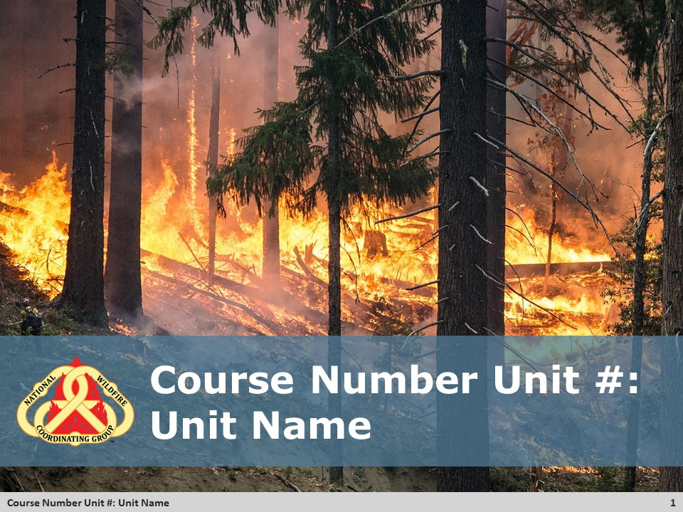
Course Overview
DO: <provide guidance to the instructor on what should be presented during the opening of a course.>

EXAMPLE
DO:
Summarize how this course will focus on how MEDLs prepare for responding to an incident.
Explain to the participants how the course is organized for learning. As a single resource MEDL unit, the following lists topics in order:
- Dispatch and receiving a resource order.
- Preparing for being away at incident.
- Information gathering before leaving for incident.
- The check-in process when arriving at incident.

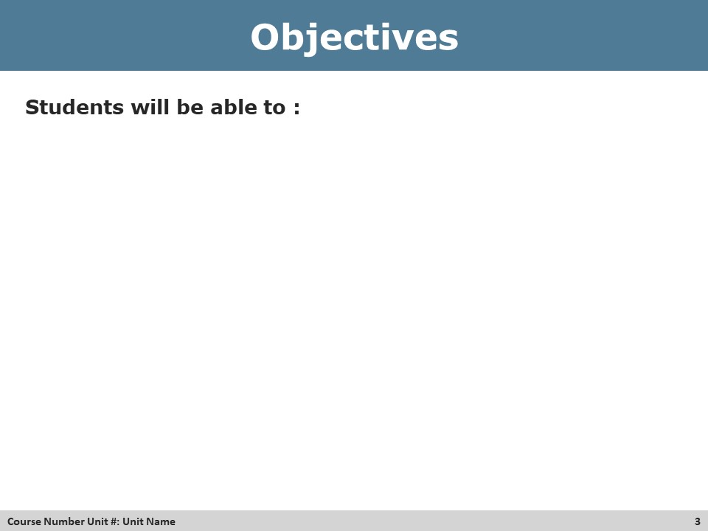
Review Course Objectives
*Note to Developer: If there is not a corresponding objectives slide, list objectives here for the instructor to relay to participants.
DO: <refer to the objectives as listed on the PowerPoint slide or list in the instructor guide when no PowerPoint slide is used.>
EXAMPLE
DO: Refer the participants to the objectives as listed in the PowerPoint slide. Allow time for the participants to review.
Handout
*Note to Developer: Make sure the name of the handout is also in the materials list for the unit.
Materials: <Name of handout>
Purpose: <Intent of the handout>
Directions:
- <provide directions for distribution>

EXAMPLE
Materials: Activity 23 Handout
Purpose:
Participants use the handout as an organizer during the instructor lecture.
Directions:
- Distribute the handout to participants of the class while explaining the purpose of the handout.

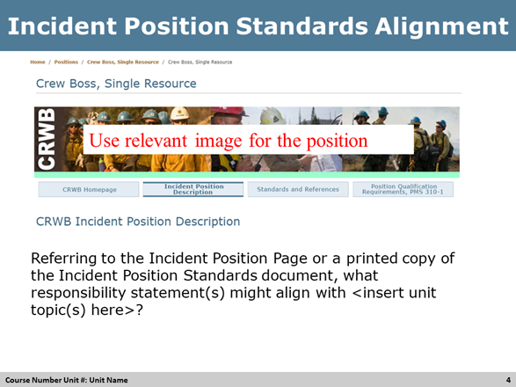
Review Incident Position Standards Alignment
*Note to Developer: Use this slide when developing instructor led course materials for Position Specific Courses. (Example: S-230, Crew Boss) and using the PowerPoint template.
EXAMPLE:
DO: Refer to the Incident Position Standards Alignment slide and allow participants a moment to review their copy of the Incident Position Standards document, specifically the Table of Contents, as it relates to the Unit’s topic.
ASK: What responsibilities statements might align with preparing for an assignment?
Answer: Listen for responses like
  - Resource Order
  - Building a kit
  - etc

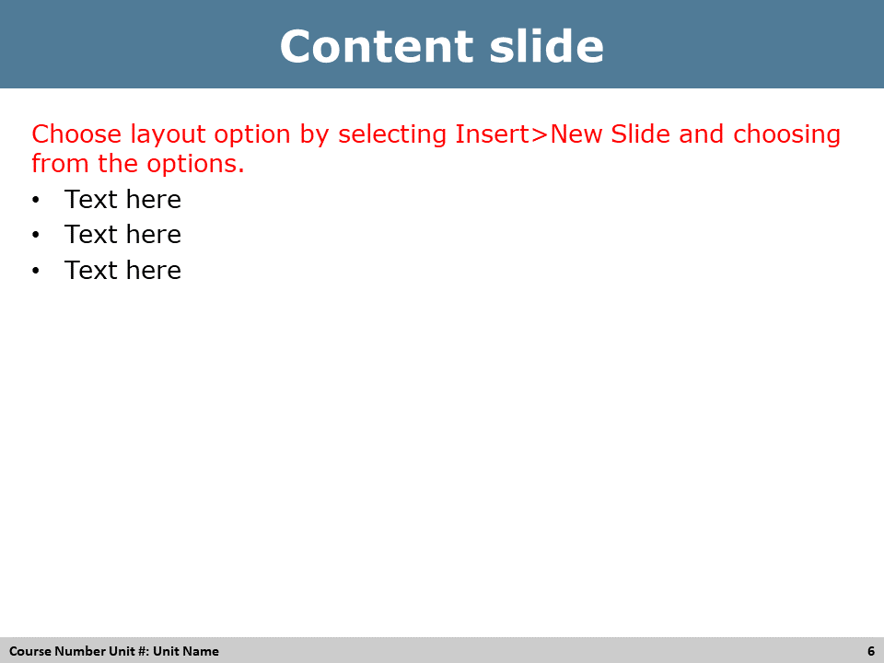
Reference Standard
*Note to Developer: Use the PowerPoint content slide when developing instructor led course materials for Position Specific Courses. (Example: S-230, Crew Boss). The Reference Standard designation can be used any time it is important to reinforce the position standard.
EXAMPLE:
DO: Refer to the PowerPoint slide to explain the Incident Position Specific Standards document aligned to this Course.

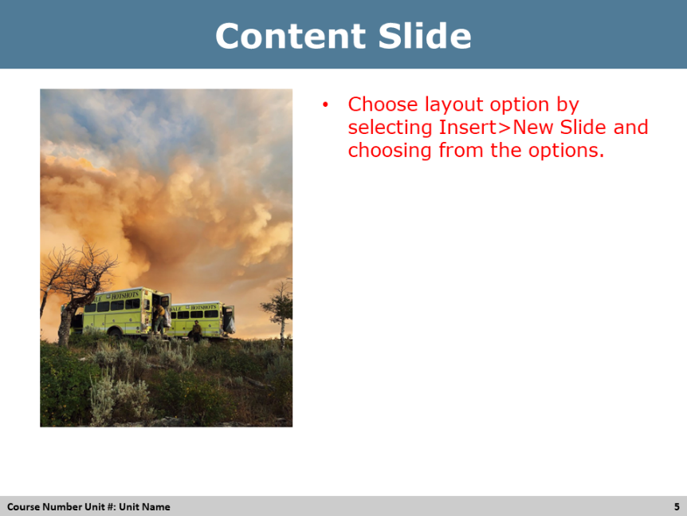
Group Discussion
*Note to Developer: Use this slide when developing instructor led course materials for Position Specific Courses. (Example: S-230, Crew Boss) Using the PowerPoint template, refer to the Incident Position Specific Standards document and the responsibility(s) aligned to this Unit.
DO: <provide instructions to guide the instructor on facilitating the group discussion.
ASK: <Write discussion question(s)>
Answer: <write possible answers>

EXAMPLE
DO: Refer participants to the corresponding PowerPoint slide listing question/topics/discussion points.
ASK: Write question here?
Answer: Listen for answers that may include…

*Note to Developer: Use this slide when developing instructor led course materials using the PowerPoint template. The Content slide is useful for short display of text, images, or other content needs that may not fit the other available PowerPoint template slide types.

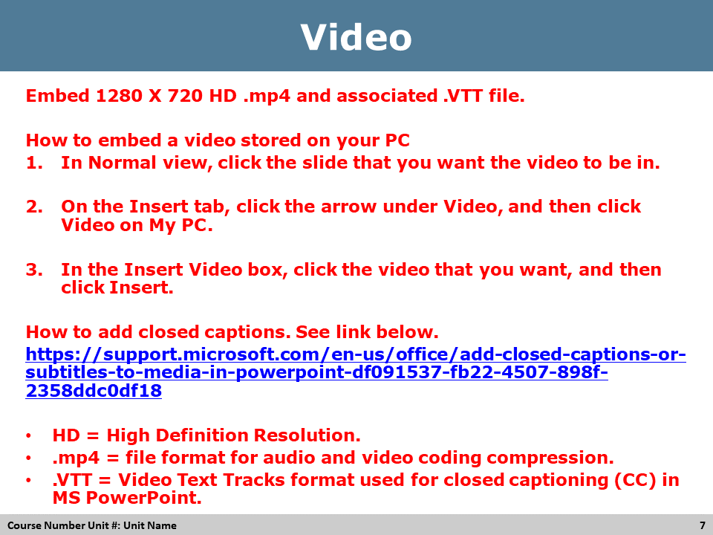
Pre-Video Discussion
*Note to Developer: This needs to be included in each video to describe the topic of the video.
Video Link: <LINK>
DO: Refer participants to the corresponding PowerPoint slide listing question/topics/discussion points.
ASK: Write question here?
Answer: Write Answer here

Play Video
Title Video Title
Summary Brief description of the video
Time (hh:mm)
Audio or No Audio
Post-Video Discussion
*Note to Developer: This needs to be included in each video to describe what was learned from the video.
ASK: <question>
Answer:<provide answer>

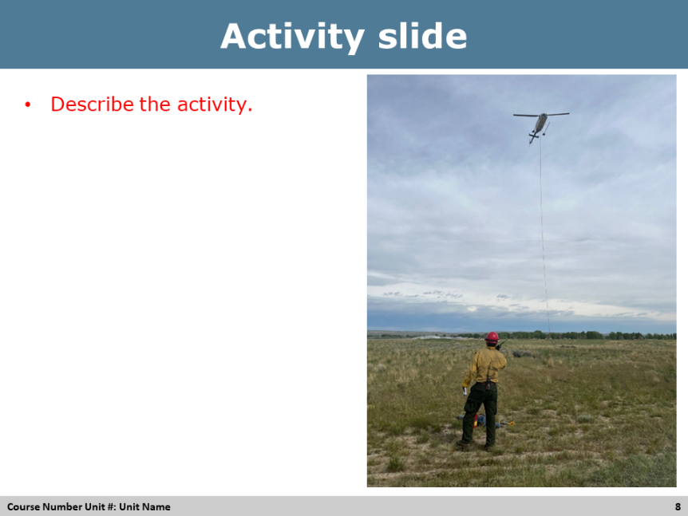
Activity
<Title of Activity, usually matching the title of the corresponding PPT slide>
Materials: List of materials that are needed for this unit. Make sure they are also in the materials list for the unit.
Length: Time in minutes.
Purpose: Write the purpose of the exercise.
Directions: Use a bulleted or numbered list to provide directions.
Activity Debrief Questions: List of questions and answers to debrief the activity with participants. Use ASK and provide answers for the instructors.
EXAMPLE
What Do We Know About Teams?
Materials: Activity Packet directions for Activity 13-2. Student provided computer for each team.
Length: 40 min. ( 15 min. activity, 20 min. report out and 15 min. debrief)
Purpose: The purpose of this activity is to provide students with the opportunity to continue to develop as a team while they recall information presented in the online portion and research new information to share with classmates on different topics that relate to the stages and elements of team development.
Directions:
- Assign one of the following topics to each team. (If there are more than four teams, assign the same topic to two teams.)
  - Stages of Team Development
  - Factors Affecting Team Cohesion
  - Team Essentials
  - Challenges to Effective Team Functioning
- Review the following directions for this activity. Tell students in their teams and using the directions in their activity packet for activity 13-2 to:
  - Tell them to select a recorder, a devil’s advocate, and a new spokesperson for this group.
  - Tell them they have 15 minutes to complete the activity.
  - Review the specific directions in the activity packet for their team assignment with their coach.
  - Tell them a will be a coach with them if they have any questions.
  - Send them to their breakout areas.
- At the end of 15 minutes, have each group spokesperson share their team findings. If assignments are doubled, have one group report out and ask the second group if they found anything different or have anything to add.
Coach Directions:
- Review the specific directions in the activity packet for this team’s assignment.
  - Answer questions and provide prompts as necessary.
  - At the end of 15 minutes, have students return to the main classroom and complete the Skill Assessment for each student.
- Virtual directions: After reviewing the activity directions, place students in breakout rooms and have the coach monitor the team’s work. At the end of 15 minutes, bring the groups back from the breakout rooms for the report out and debrief.
Activity Debrief Questions:
ASK: <question>
Answer:<provide answer>

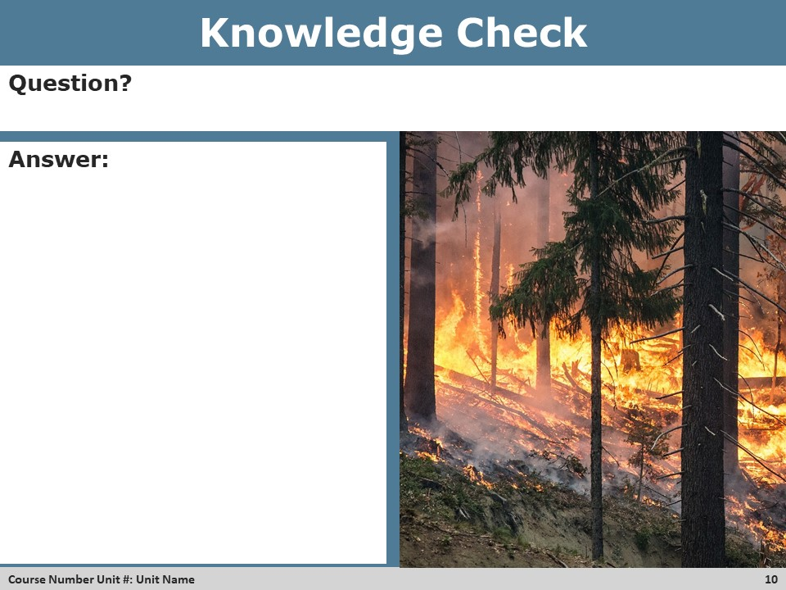
Knowledge Check Discussion
DO: <provide direction to the instructor on the purpose and use of the knowledge check slide.>
ASK: <Ask to see what questions the participants may have about the question and answer provided.>
Answer: Respond to questions as needed.

EXAMPLE
DO:
- Review the Knowledge Check Question with the participants.

- Call on a participant(s) to provide an answer to the question.

- Display the answer on the PowerPoint slide.

ASK: What questions do you have?

Answer: Respond to questions as needed.
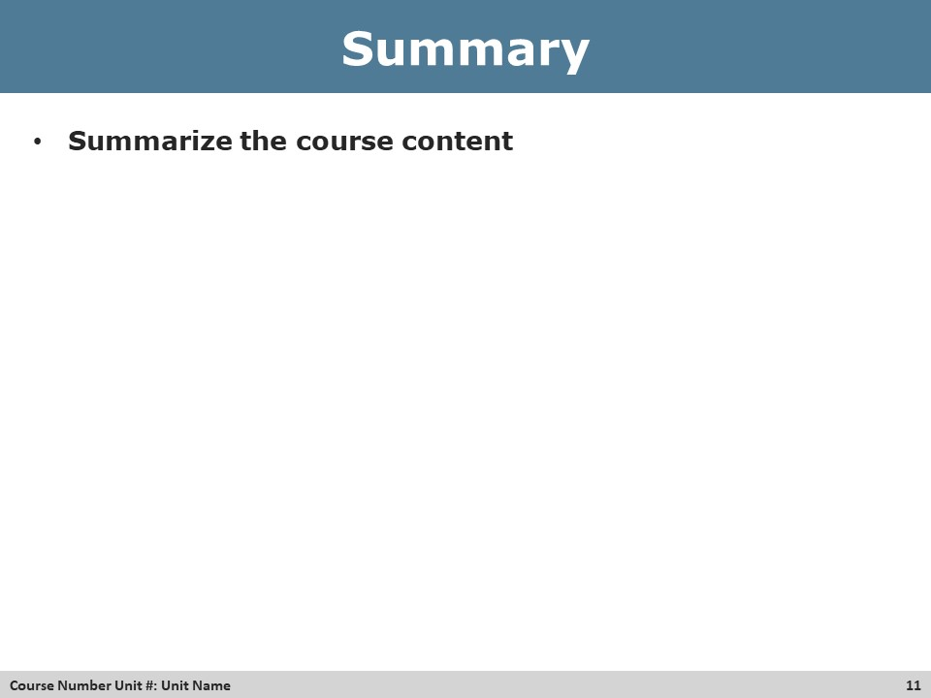
Summary
DO: <Provide direction to the instructor on how to facilitate the summary.>

EXAMPLE
DO:
- Refer to the PowerPoint Summary slide.
- Review with participants the learning outcomes of the course.

